Introduction to GIS: Lab 6

Part Two: Uploading, Inputting, and Editing Data

This week, we’ll be taking our global positioning system data and uploading these locations into ArcGIS Pro for mapping and manipulation. As you remember from lecture, we can create datasets from many types of data, and point data is one of the most common, and easiest.

For this exercise, you will input your X,Y data into a spreadsheet and see how to create a shapefile from that information. You’ll work with creating and manipulating other vector features as well, from digitizing lines to calculating areas from shapes you’ve created. You’ll produce a map of campus along with a hypothetical campus tour of the points you investigated. Did you forget your data sheet from the scavenger hunt? Borrow one from a neighbor or ask us for help!

Part two of Lab 5 is divided into two parts, which you should complete in order:

Part A: Importing GPS Coordinates as a Shapefile
Objective: Learn how to input information from a csv file into ArcGIS Pro and make a shapefile.
Part B: Creating a New Shapefile
Objective: Make a shapefile from scratch, and put some features in it!
Part C: Lab Production, Digitizing Information on Your Walking Tour
Objective: Make a campus map and tour including the points you collected.

Part A: Importing GPS Coordinates as a Shapefile

Summary: Dig into a spreadsheet to set up data you’ve collected for display in ArcGIS Pro – and once in Pro, select some imagery to use as a basemap!

Geospatial Technology Competency Model: 5.2.23.2, 5.1.26.8, 4.1.10.8, 4.1.10.7, 4.1.3.3, 3.5.2, 3.5.1, 3.3, 3.2, 2.4.2.3, 1.5.2

Link to Video Walkthrough

- To import GPS coordinates gathered by hand, we have to set up our data correctly so that ArcGIS Pro can read our information as latitude and longitude points. This is easiest to set up in Excel.

- Open a new Excel file. We’ll be using three columns for our data, so in columns A, B, and C, give them the titles: Lat, Lon, and Descript. Type in the coordinates for the locations you identified in your scavenger hunt. In the third column, type a description of the location. Make sure you’re using the same coordinate system (decimal degrees!) for all of them!

- Also, remember your signs – Are coordinates in the Western Hemisphere positive or negative? What about coordinates in the Northern Hemisphere?

- Save the Excel file either as the new Excel default (.xlsx) or as a .csv. ArcPro can handle either just fine – you might need one or the other depending on your workflow with other programs, preferences, etc.

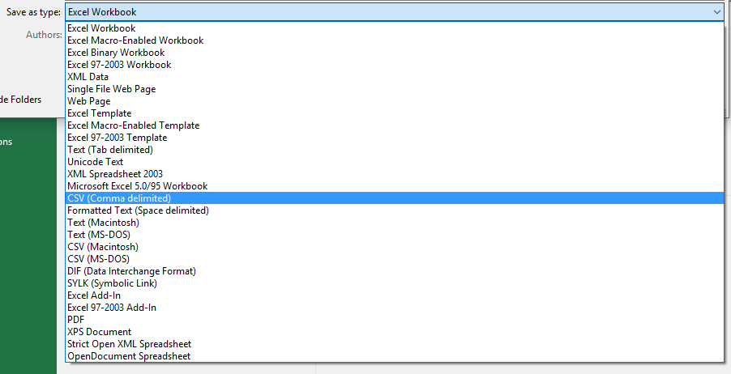

- Make sure to close Excel after you have saved your data. Excel will put a lock on your spreadsheet if it is still open – we want Arc to have *full access* to the spreadsheet for conversion.

- Head into ArcGIS Pro and add the data into your Project.

- Right click on the excel file in the Contents pane, right click on the table, and select Display XY Data. Alternatively, click on Add Data in the Map tab and choose XY Point Data.

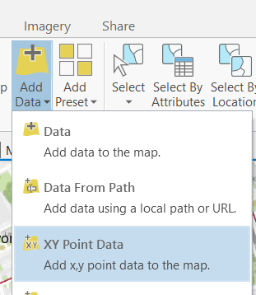

- This will bring up a geoprocessing pane that allows you to specify the appropriate X and Y values. Specify the coordinate system as GCS with the datum WGS 1984.

- Hit OK and a new shapefile will appear. Wherever you set the tool previously to create this shapefile – the new shapefile lives. Nice!

- We’d like to see the campus, or wherever you collected your locations, as it would look like from an aerial view – and we have two options to make that happen.

  - First, we could change the basemap. The lovely topographic basemap is not our only option! In the map tab layer group, click on the basemap icon. The first option is imagery – give that a go!

  - Alternatively, if your points are on campus, we could add the raster file UMass_ortho.jp2. The default basemap might not always serve our needs for specific time points, resolution, etc.

  - Which one to use? Whichever one you want!

    - Whichever you use, make sure to set the Map’s coordinate system to be the same as the imagery you are using. This is a secret tip that will help us later.

- Are your point locations where you expect them to be relative to the UMass campus? If so, congratulations! That’s all it takes to import GPS point locations that you collected into ArcGIS.

Part B: Creating a New Shapefile

Summary: Create new shapefiles from using imagery from the UMass campus, and practice with the editing tool and some data organization.

GTCM: 5.2.23.2, 5.1.26.8, 4.1.10.8, 4.1.10.7, 4.1.6.2, 4.1.3.3, 3.5.2, 3.5.1, 3.3, 3.2, 2.4.2.3, 1.5.2

Link to Video Walkthrough

- Oftentimes you’ll want to create a new shapefile and draw your own features.

- Create a new Map. And add the UMass campus ortho image file (UMass_ortho.jp2) in the lab 5 data.

- Navigate to your Lab 5 directory in the Catalog pane. If you haven’t been using the catalog pane to use your data, now is the time to start!

- To create a new shapefile, right click on the folder in the Catalog pane where you want it to go → New → Shapefile.

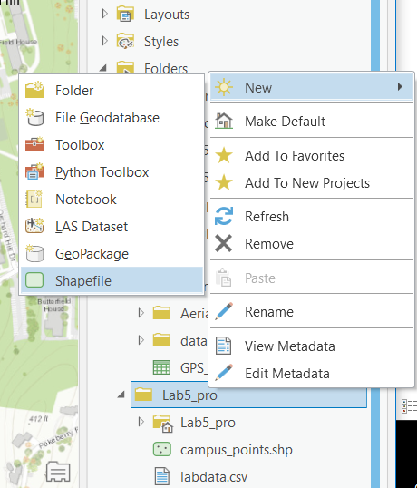

- Create a new polygon shapefile and name it campus_buildings. Set the coordinate system to be the same as whatever imagery source you are using.

  - For UMass_ortho.jp2, that’s: (Projected -> UTM -> NAD 1983 -> NAD_1983_UTM_18N).

  - If you’d rather use the World Imagery Layer, that’s: (Projected -> World -> WGS 1984 Web Mercator (auxiliary sphere)).

  - We use the same coordinate system as our imagery to reduce potential distortion in our digitizing.

  - Remember as well that your Map document should be set to this same coordinate system. Everything aligned – no distortions!

- Note that the new shapefile added to the map is empty. Nothing appears because you haven’t yet created any polygons!

- Zoom in on Holdsworth Hall on the UMass campus.

- To add features to the new shapefile, click on the Edit tab at the top of the document, and click ‘Create’ in the Features group. The Create Features pane will pop up.

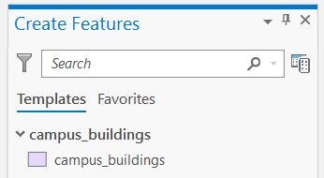

- Under templates, click on campus_buildings. This will make the campus_buildings shapefile the active template, and a series of construction tools to choose from will be visible. Hover over these tools to see what your construction options are. A toolbar also appears at the bottom of the active map containing companion commands for creating and finishing a feature.

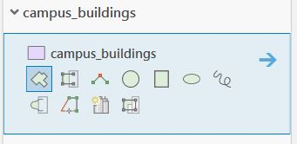

- Under the construction tools select the basic polygon construction tool.

- Create a shapefile of Holdsworth by clicking once on your map to create a new point at each corner, and double clicking to complete the polygon.

- Save your edits by clicking ‘Save’ in the Manage Edits group.

- While editing, you can change your other files as well. If you wanted to, you could select the points you just imported (under templates), add new points, move them around, and delete them. Cool!

- Notice that depending on which layer type you clicked on under templates, the construction tools change. When creating features, you need to select a polygon layer to create polygons or other shapes, a line layer to create lines, and a point layer for points.

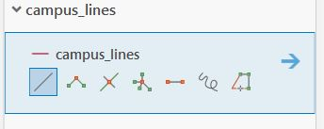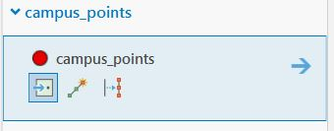

- To add lines to your project, you’ll need to create another new shapefile in the Catalog pane. Call this file ‘campus_lines’, and choose ‘Polyline’ for Geometry Type.

- Remember that you can’t edit the aerial image/basemap themselves! They are just being used as a reference.

- Make another new shapefile, called ‘Campus_Pond’. Draw a polygon around the pond, first using the polygon tool and then using the freehand tool. Which tool do you like best for this task?

Part C, Lab Production: Digitizing Information Along a Walking Tour

Link to Video Walkthrough

In the map production part of the lab, you’ll create a walking tour of UMass, or a different location of your choice.

Your walker would like to find a nice spot to eat lunch along the way and a location with a nice view. If you didn’t take a picture, download a picture from the internet of a view from your nice view location.

Create points of the different locations that your pedestrian will visit, and create a line file showing a recommended route.

Map

Map Criteria: UMass Walking Tour
A map of the UMass campus showing the 7 locations. All of the locations must be labeled.

Your walking tour must include 7 stops:

- Walking tour starting point at Orchard Hill
- Whitmore Administration Building
- The Integrated Science Building
- Holdsworth Hall
- The Minuteman Statue
- A nice lunch spot
- A place with a nice view. Include a picture.

Map Criteria: Non-UMass Walking Tour
You may make a walking tour map of a different location, such as your neighborhood.

Your walking tour must include 7 stops:

- A starting point
- Four points of interest (such as buildings, lakes, etc.)
- A spot to have lunch.
- A place with a nice view. Include a picture.

In addition, you must include an aerial imagery basemap.

General Map Criteria

- Your maps must have all 7 points clearly labeled, both with a point and a text label.
- Make sure that you guide your pedestrian along walkable paths (no walking across the campus pond or through walls of a building).
- Be sure to include a scale bar and north arrow on your map.

WVD Users: I’ve tested the aerial imagery basemap functionality in WVD in my browser. It works great and is quite fast.

Lab Questions

- What is the total length, in meters, of your walking tour?
- What is the area of the campus pond (in m²)?

Lab Report
You will submit your work in a single pdf file containing the following:
1. Your answers to lab questions
2. Your map (make sure you double check all of the map requirements)
• Export your map as a png image. You can then insert the map image into your report (in Word, Google Docs, etc).
• Remember to convert that file to .pdf before submitting on Moodle!

University of Massachusetts – Amherst, ArcGIS Pro Edition Written by Forrest J. Bowlick, Bethany Bradley, Sophie Argetsinger, Steven Bittner, Brit Laginhas, Chloe Thompson, Connor Hughes, and many others
Includes components from the field data collection component of this lab (Part One)
They’re negative.
Positive, batman.
File -> Save as -> Select your file’s location -> Save as type -> CSV (comma delimited)
Longitude is X and Latitude is Y
This is what the GPS units/Google Maps/Your Phone are all using, under the hood.
If not, check the attribute table of your new shapefile. Did you type the coordinates correctly? Did you assign the correct x, y values? Are the longitudes negative and the latitudes positive?
Includes components from the field data collection component of this lab (Part One)
Build the habit in yourself of naming the file something intuitive when you create it. Nothing will make you crazier than trying to find the file you want amongst ‘New Shapefile; New Shapefile 1; New Shapefile 2; New Shapefile 37.’
Though shapefiles (and vector files in general) can be points, lines, or polygons, they can only contain one of those geometries in a single file. This is a limitation of the shapefile format; some other vector file formats are more flexible.

