Introduction to GIS: Lab 5

Coordinate Systems and Map Projections

Important format change!

You will hand in the answers to the red numbered and underlined questions scattered through this lab in addition to end lab production. Make sure you answer these questions as you work!

This week, we change modes a little and begin work on a set of underpinnings of all the spatial data we work with – projections and coordinate systems. Technically and mathematically challenging, projections will cause you problems if not handled appropriately. This lab will focus on practicing with problematic projections and using projected data in different ways. Throughout, you will be challenged with questions regarding this process, and a (shorter than usual) production activity at the end will put your skills to work.

The data for this lab is available on Moodle in our week four folder. Please download and unzip your files per your workflow.

This lab is divided into eight parts, which you should complete in order:

Part A: Projection Background Information

Objective: Learn about the foundational functions and concepts of projections and coordinate systems as they function within ArcGIS Pro.

Part B: Introduction to Map Projections in ArcGIS Pro

Objective: Begin working with projections and consider their function in ArcGIS.
Part C: Changing Projections

Objective: Manipulate ArcGIS by changing projections of shapefiles and maps.

Part D: Many Projections, Many Uses

Objective: Explore additional means of viewing spatial data, including projected data as compared to geographic data, and how to reproject data in many forms.

Part E: Your Worst Nightmare: The Undefined Coordinate System

Objective: Encounter a wild Rhode Island shapefile that doesn’t have any projection information at all, then learn how to fix it!

Part F: Learning about UTM

Objective: Familiarize yourself with a standard projection and grid reference format for the world, the Universal Transverse Mercator.

Part G: Datums, or Which Lumpy Space Potato will you use Today?

Objective: Briefly explore how to see and manipulate the datums within ArcGIS Pro.

Part H: Lab Production: Finding Farmer William’s Fields: Working with Field Data and Managing Projections

Objective: Put your projection skills to work by helping a farmer out with their field data.

Part A: Projection Background Information

Summary: This section provides some fundamental details on how projections operate within a GIS – not just in ArcGIS Pro. Reading through and understanding this section will assist you in the remainder of the lab. Please note there is no video walkthrough for this section

Geospatial Technology Competency Model: 5.1.26.5, 5.1.26.4, 5.1.26.3, 5.1.1, 4.1.14.3, 4.1.10.4, 4.1.10.2, 4.1.10.1, 4.1.1.4, 4.1.1.2, 4.1.1.1, 2.7.1, 2.4.2

This lab focuses on a fundamental function of a Geographic Information System: its ability to translate spatial coordinates into and between projections. As with other modern GIS systems, ArcGIS Pro allows the user to accomplish this in two ways. ArcGIS Pro can project geographic data from the geographic coordinate system it is stored in to any other as specified for display. This is accomplished in real time and is often informally referred to as projecting “on the fly.” GIS systems (in the case of ArcGIS, found within the Toolbox) also provide a user the ability to permanently transform a geographic dataset from one map projection into another. Both approaches have their advantages and disadvantages.

Before you begin learning how to implement map projections in a GIS, a process which has gotten much easier and much better over time, a few pertinent points need to be made.

- First and foremost, while a GIS can transform geographic coordinates from any number of map projections to another, it is up to you, dear GIS user, to understand the strengths and weaknesses of a particular map projection and whether its use is appropriate.

- Within a GIS, spatial coordinates can be stored either in spherical coordinates (latitude/longitudes) or in Cartesian coordinates (x, y within a particular map projection). Either of these formats are coordinate systems (CS). When spatial information is stored as latitude and longitude it is unprojected and can be more formally said to be in a geographic coordinate system (GCS).

- Conversely, GIS data whose spatial coordinates are stored as Cartesian coordinates within a specified map projection are projected and are formally described as a projected coordinate system (PCS).

- Here’s a quick list to help you differentiate between a PCS (projected) and a GCS (unprojected).

Unprojected (GCS) | Projected (PCS)
- Has GCS and datum defined  - Map units are decimal degrees  - Has no projection in CS definition | - Has GCS and datum defined  - Map units in feet or meters (rarely others)  - Has projection in CS definition

- Because the mathematics of dealing with information in spherical and Cartesian coordinates differ greatly, for most GIS analytical operations it is required that the data be projected – or stored in a projected coordinate system.

- However, if the primary use of a particular GIS theme is for visualization, where the data might be transformed ‘on the fly’ into different views and different contexts, it may be preferable to store the coordinate information in a geographic coordinate system.

- Proper use of datums is vital in GIS. Whereas early GIS systems accommodated datum differences poorly, if at all, today’s GIS systems properly handle the different ellipsoids, tie points, etc. used by different datums. Datums are most important for large-scale mapping. Consider that a location difference of 200 m attributable to incorrect datums may be inconsequential for a world map, it may be devastating to the utility of a map locating a water well in a farm field.

GIS offers flexibility in creating maps with map projections tailored specifically to the problem at hand (unheard in old-fashioned pen and ink cartography). Take advantage of this technology but be sure to use it correctly. One example: in a GIS, “Holdsworth Hall” could be represented as “72.53˚W, 42.39˚N”. Those numbers are probably familiar to you – they’re in decimal degrees, with lines of latitude moving north from the equator and lines of longitude moving west from the prime meridian.

You probably aren’t as familiar with another possible representation of the location of Holdsworth: “115120E, 905220N”.

Part B: Introduction to Map Projections in ArcGIS Pro

Summary: Begin to work with projections in ArcGIS Pro and understand how the program responds to the native projections of files you use.

GTCM: 5.1.26.5, 5.1.26.4, 5.1.26.3, 5.1.1, 4.1.14.3, 4.1.10.4, 4.1.10.2, 4.1.10.1, 4.1.1.4, 4.1.1.2, 4.1.1.1, 2.7.1, 2.4.2

Link to Video Walkthrough

- Open ArcGIS Pro and add the file ‘mtholyoke’ from your lab data folder. Zoom in on part of the grid and take a look at the x, y coordinates at the bottom middle of the display – they’ll look something like this:

- Move the cursor around the map and notice that the numbers change. As you move east to west, the values on the left change, as you move north to south, the values on the right change.

- As you learned in lecture, it is a challenge to represent a spheroid like the earth on a flat plane. No matter what you do, you always have some level of distortion. The mtholyoke file is projected using a conic projection designed to best represent the state of Massachusetts with as little distortion as possible. The units are in meters, and the origin (0,0 point) is located somewhere in the Atlantic off the coast of North Carolina.

- This projection is the standard one that you’d get when downloading data from MassGIS – it’s also known as “Massachusetts State Plane – Mainland NAD83”. Here’s what the world looks like using a Prime Meridian centered conic projection:

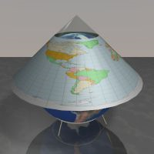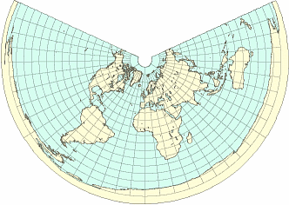

- Let’s check this out in ArcGIS. Add the states shapefile from your lab data folder to the Project. This shapefile has a different projection from the mtholyoke layer, but you might never know! ArcGIS Pro reprojects data on the fly so any data you add to a map adopts the coordinate system definition of the first layer added. As long as the first layer added has its coordinate system correctly defined, all other data that has correct coordinate system information reprojects on the fly to the coordinate system of the map.

KEY POINT
Arc is capable of displaying ‘on the fly’ and can display both of these layers despite two (or more) different coordinate systems.

- The default map that appears when you open a new Map project has the Projected Coordinate System WGS 1984 Web Mercator Auxiliary Sphere.

- When you added the mtholyoke layer, the map automatically switched to display as a conical projection (matching the mtholyoke spatial reference).

- When you added the states shapefile, Arc automatically matched the states’ coordinate system to display the same way as the first file you added (mtholyoke).

Keep this is mind moving forward!

Part C: Changing Projections

Summary: In this section you’ll track the impact of changing projections and look closely at what happens to the way your data looks when you do make a change.

GTCM: 5.1.26.5, 5.1.26.4, 5.1.26.3, 5.1.1, 4.1.14.3, 4.1.10.4, 4.1.10.2, 4.1.10.1, 4.1.1.4, 4.1.1.2, 4.1.1.1, 2.7.1, 2.4.2

Link to Video Walkthrough

- The projection of a map in ArcGIS Pro (or a data frame in old Arc Desktop) default to the coordinate system of whichever layer (shapefile, grid) you add first. If the first thing you add does not have a defined projection, then the Map will keep the default topographic basemap’s projection.

- Zoom to the full extent of states and check out how it looks in the display – it should be reminiscent of the conic projection image in the previous section.

- In the Contents pane, right click Map > Properties. In the window that opens, go to Coordinate Systems.

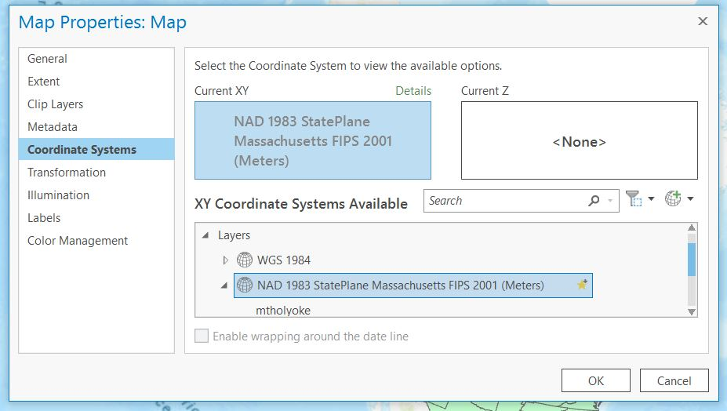

- Here you can see the current coordinate system (in the ‘Current XY’ box) and where it sits in the many coordinate systems you have available to you (in the ‘XY Coordinate Systems Available’ box).

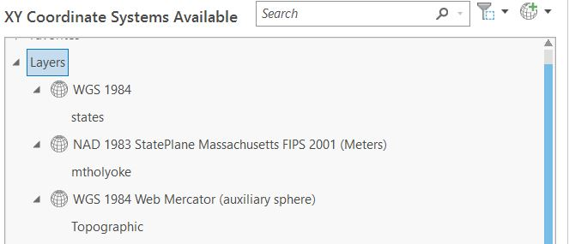

- Under the Layers section of this box, you can see the projections that belong to the layers in your map. If you expand Layers like the image above, you can see the three different projections of your layers. This shows you that your current coordinate system is based on mtholyoke (since the mtholyoke layer matches Current XY).

- Click on WGS 1984, the native unprojected format for ‘states.’ The Current XY will switch to WGS 1984. Click OK.

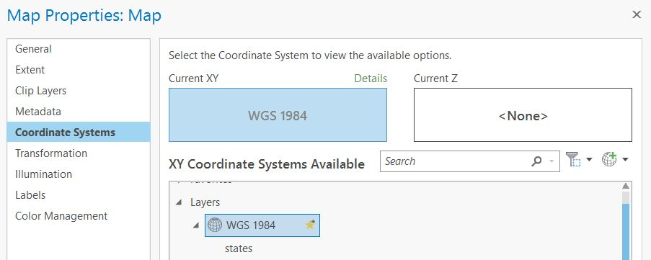

KEY POINT
By assigning an unprojected coordinate system (WGS 1984) for the data frame’s display, you have removed the projection from the display of the mtholyoke file rather than show its projected form. The file still has its projected information: we’re just displaying it differently. You didn’t change the data in the file, only the way it looks.

- Zoom to the layer extent of ‘states.’ Looks different, right? Now zoom to the layer extent of mtholyoke. It looks different too! Almost like it has been squished!

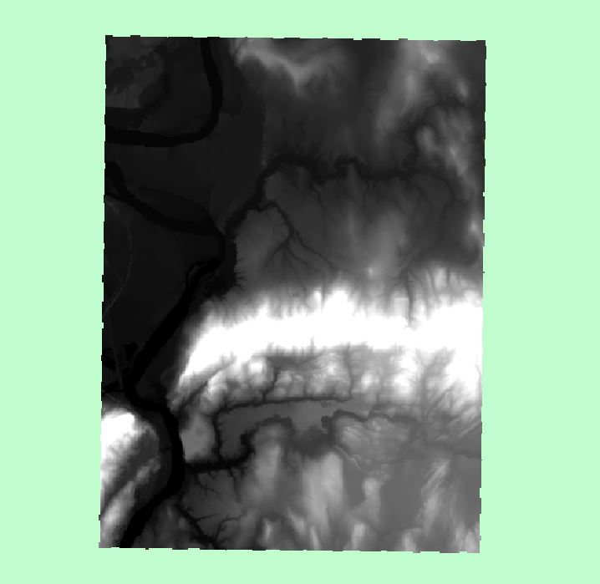
State Plane (PCS, projected) Display

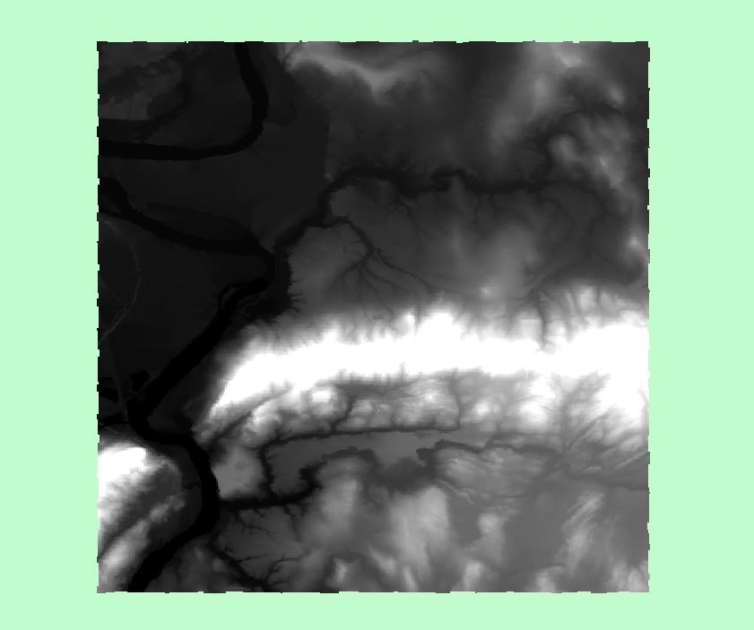
WGS 1984 (GCS, unprojected) Display

- Let’s find out what myholyoke should look like. Right click on mtholyoke and go to Properties.

- Under the Source tab > Raster information note the ‘Cell Size (X, Y)’ of each pixel in this image. Given the dimensions, what shape should each pixel be?

- Look at the ‘Columns and Rows’ information as well. Given these dimensions, what shape should the entire file be?

- Zoom in really close on the north edge of the range. Look for a pixel that stands out from the background.

- Are the pixels the shape you expected to see when you looked at the properties of the source? A formal way to ask this question is:

Question 1: Why don’t the pixels appear square in this view?

Part D: Many Projections, Many Uses

Summary: Explore the many projections available to you, and make a formal reprojection of some files to see what happens!

GTCM: 5.1.26.5, 5.1.26.4, 5.1.26.3, 5.1.1, 4.1.14.3, 4.1.10.4, 4.1.10.2, 4.1.10.1, 4.1.1.4, 4.1.1.2, 4.1.1.1, 2.7.1, 2.4.2

Link to Video Walkthrough

- Although Geographic Coordinate Systems (GCS) are always in units of latitude and longitude, projected coordinate systems are always in units of distance (most commonly meters or feet). There are *lots* of projections out there, as you’ll see if you start opening folders under ‘Projected Coordinate Systems’.

- Let’s check out some Projected Coordinate System options by changing the look of the map display. Go back to the Coordinate System tab in Map Properties, navigate to Projected Coordinate Systems > Polar > North Pole Stereographic.

- Click ‘OK’ and zoom back to the Mt Holyoke topographic map. Is this projection appropriate for displaying mtholyoke? Which way is north?

- Changing the projection of the Map will alter the look of your data but will not change the underlying projection of your data (we’ll do that next). Some projections will be more appropriate for representing your data than others.

Practice: Set the Map projection to UTM (Universal Transverse Mercator), WGS84 (Datum), Zone 19N. This is a commonly used projection for areas in New England. Mt. Holyoke should look pretty ‘normal’ when you zoom to the layer.

- In the section above, you applied different Coordinate Systems containing different map projections to a map containing layers representing geographic features. However, the coordinate system of the map is not necessarily the same as the native/defined coordinate system of the individual layers you have added to the data frame. You know this because the two layers you’ve been working with (states and mtholyoke) have two different native projections (Geographic and MA State Plane respectively).

- As you know, you can use the Map Properties to project your map in the same projection as the layers, or a totally different projection depending on how you want to represent your data. In some circumstances, particularly if you are using certain spatial data frequently, using specific models or methods that require specific projections, or performing multiple spatial processes on your data, you might want to keep all of your data layers in the same projection. This requires reprojecting your data. This is different from just changing the projection of the display. Now, we want to change the way the data are stored and formatted.

- The easiest way to do this is through ArcGIS Pro. Let’s reproject mtholyoke so that its native projection is UTM rather than MA State Plane.

- Fortunately for us, as we learned last week, ArcGIS has many tools to help us out with tasks like this. Let’s search for a tool to help us project a file.

- Go to the Analysis tab > Tools, and type ‘project’ into the search bar. You’ll see 20+ tools, but we’re interested in two: Project (Data Management Tools) and Project Raster (Data Management Tools).

- We’re interested first in projecting our mtholyoke file. Since it is a grid file made up of cells, which one of these should we use?

- That’s right, we should use ‘Project Raster.’

- The tool looks something like this:

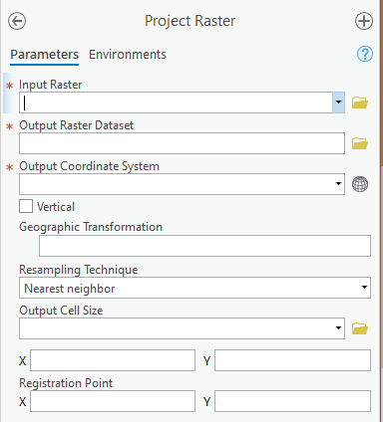

- The input file is our current mtholyoke raster. Name your output dataset ‘mtholyoke_UTM’, so that you know what projection this new file is in without having to load it and peek into the file properties.

- To set the output coordinate system, click on the little globe next to the field and navigate to the coordinate system you’re looking for.

- Choose UTM (Universal Transverse Mercator), WGS84 (Datum), Zone 19N, since you know how to navigate there already. We won’t worry about the rest of the options. If your Map is still in this coordinate system from the last section, you can click on the drop-down menu and choose ‘Current Map.’

- Your new file will automatically be added to your Map.

- Navigate back to the Coordinate System tab in Map Properties and notice how the two mtholyoke files now have two different native projections under the Layers tab.

- Zoom in on the north edge of the range again and compare the two mtholyoke layers by turning one on and off in the display. You should see that the location of the pixels has moved slightly.

Key Point
You just changed your data. Remember that a raster is made up of grid cells (pixels) that correspond to a specific geographic area. By reprojecting your raster, you calculated (and created) a new file that changed how these cells are stored. You can see this by the difference between the pixels in the mtholyoke file. Remember that each type of projection preserves something different about the data you have and will thus warp your raster files when you reproject them. As usual, the original file remains unchanged, but your output (reprojected) raster file may have different characteristics.

Question 2: Reprojecting (or, changing the projection of) raster layers creates some level of distortion in the data. Explain why.

- Now let’s reproject a vector shapefile. You’ll notice when working more with ArcGIS that processes performed for raster data are often similar, but rarely identical to processes performed for vector data.

- Go back to your tool search and choose ‘Project.’ This is the version of the tool for vector datasets.

- Input your states file. Give it a name that corresponds to the output coordinate system you want it to have. Assign it some projected coordinate system you think is interesting.

- Once the layer is added to the map, zoom in to a border of a polygon and switch between the files.

Key Point
You’ve changed your data again! This time, there doesn’t appear to be a data problem like our raster data. Think back to how vector data is stored: as points, lines, and polygons. This is a different format from the grid cells (or pixels) of a raster file. Vector features are much easier to manipulate computationally, so shifting between projections doesn’t cause distortion.

But how can you be sure that the new file you created is actually in a different projection? It looks like whatever the Map is set to, as ArcGIS is trying to keep things together by projecting them on the fly. Let’s insert add a new map and add in your newly reprojected states file. Does it look different from the original when you switch back and forth?

Question 3: Reprojecting vector layers does not create distortion, i.e. it is reversible, in the data. Explain why.

Part E: Your Worst Nightmare: The Undefined Coordinate System

Summary: While reprojecting intentionally is tough enough, sometimes you’ll encounter data without a projection at all! In this section you’ll see how to approach and hopefully fix this quandary.

GTCM: 5.1.26.5, 5.1.26.4, 5.1.26.3, 5.1.1, 4.1.14.3, 4.1.10.4, 4.1.10.2, 4.1.10.1, 4.1.1.4, 4.1.1.2, 4.1.1.1, 2.7.1, 2.4.2

Link to Video Walkthrough

- Sometimes when you’re working with spatial data you may come across a data file that doesn’t appear to have a coordinate system. In these instances, ArcGIS Pro may present a Warning box indicating that the coordinate system is unknown.

- Start a new Project or insert a new Map and add the shapefile ‘ri_noprj’ to the map. You’ll see something like the error message below pop up briefly in the upper right corner of your screen.

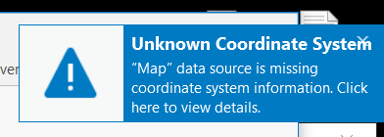

- If you navigate to the Coordinate Systems tab of the Map’s Properties, you’ll see that the coordinate system of the Map remains the same as the default Topographic map (WGS 1984 Web Mercator Auxiliary Sphere). The new layer, ri_noprj, is listed under an “Unknown” coordinate system. This is because ArcMap requires a specific file to be associated with the data from which it “reads” the coordinate system. This file is the “projection file” (aka the .prj file) for vector files and grids; or for images, the “world file” (aka the .hdr, .jpw, .tfw or .sdw depending on the image format). Without a projection file, ArcGIS has no idea what the projection is…and so, we run into trouble.

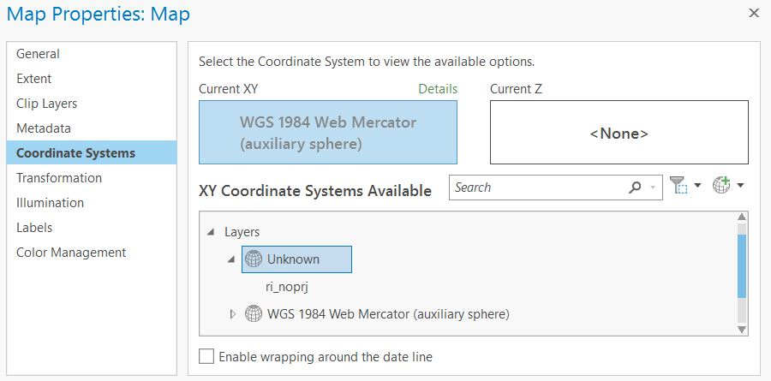

- Although our file has no projection information, ArcGIS Pro can still draw it. Zoom to the ri_noprj layer, and notice that a landform shaped suspiciously like Rhode Island has landed somewhere in the Gulf of Guinea.

- You can confirm that this shapefile has no projection information by going to the Source tab in its properties (right click > Properties > Source > Spatial Reference = Unknown Coordinate System).

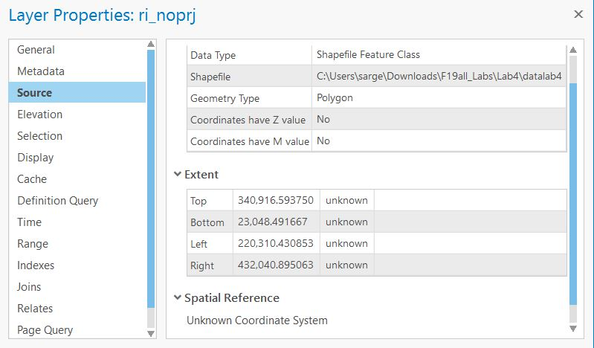

- We do have an important piece of information here however, which is the extent of the file. Though no coordinate system exists, we have some mystery units available to us for our detective work.

- We know from the previous sections that files stored in a GCS have their location stored as latitude and longitude (like states.shp), and that files stored as PCS have their location information stored in another unit, like feet or meters (like mtholyoke).

- So what projection is this file stored in based on its extent? Do those values look like lat/long data or something else? Or, more formally:

Question 4: Is the native projection of this shapefile a Geographic Coordinate System? Why or why not?

- How do we figure out what the native projection is for this layer? This can be a challenge! Generally, you’ll want to start by looking for the metadata that came with a file. Sometimes these files will say ‘metadata’ in the filename, sometimes they’ll be called ‘readme’, or sometimes they’ll have less obvious names. There is often some spatial information in a text file or elsewhere. Another thing to consider is the source of your data. Did you download it from MassGIS? In that case, it’s likely to be in MA State Plane projection. Did you download other data along with this one? They might have the same projection. Sometimes this just requires guess work…UTM projections are very commonly used, as are geographic projections. Those are good places to start if you ever run into this problem.

- You’ll need to consider the suggestions in the previous step to track down the projection info for this file.

- To define a projection, we can conveniently use the ‘Define Projection’ tool. This tool only needs two inputs: the file without a projection (or with an incorrect one), and the correct projection. Navigate to the correct projection, and define the projection.

- Huge caveat here. Generally, when you run a tool within ArcGIS Pro, it creates a new file as the output of your tool, and the original file is unchanged. The Define Projection tool breaks that pattern. It will append the defined projection to your file, and not create a new shapefile at all! So, it’s good to make copies of your data before defining their projections away and potentially rendering them spaceless. Fortunately, you kept a copy of the zipped lab data, which you can use as a reference.

- Your data should be aligned now: after all, you’ve given Rhode Island the projection it needs to exist as an object on the map. If your data is still not aligning, set the projection of you whole Map to the same projection as you defined the Rhode Island file. This should update the viewer to project the states layer on the fly.

Here’s a handy way to remember these differences:

Define Projection | Project tool
- Changes the file’s source projection.  - Does not change coordinates.  - Keeps original data set.  - Use only when CS is unknown or incorrect. | - Changes coordinates in file.  - Changes definition also.  - Creates new data set.  - Use when changing a coordinate system permanently.

Part F: Learning about UTM

Summary: Despite the numerous projections available, there are some standard ones used in the GIS community. We’ll learn about one here, UTM.

GTCM: 5.1.26.5, 5.1.26.4, 5.1.26.3, 5.1.1, 4.1.14.3, 4.1.10.4, 4.1.10.2, 4.1.10.1, 4.1.1.4, 4.1.1.2, 4.1.1.1, 2.7.1, 2.4.2

Link to Video Walkthrough

- UTM is short for “Universal Transverse Mercator.” We’re going to spend a little time playing with this one, so you can better understand this commonly used coordinate system.

- Add a new Map and add the layers cntry04.shp and utmzone.shp from the datalab3 folder. Put cntry04 on top and make it hollow so you can see the UTM zones through it.

- UTM is widely used as it is a worldwide reference for xy coordinates, as opposed to a “local reference system”, like the State Planes we’ve been using.

- Because UTM is a worldwide reference system, satellite imagery (remotely sensed data) is often provided in this format. In this system, geographic features in a layer are projected using the Transverse Mercator projection algorithm.

- In addition to the projection, the entire globe has been divided up into sixty “zones” of longitude and one of these zones is another defining parameter of the UTM coordinate system for any given spatial data file. A UTM name has two parts: a zone number and an indication of whether it is in the northern (N) or southern (S) hemisphere.

Question 5: What is the native coordinate system of the utmzone.shp file?

- Display utmzones such that each ‘Zone’ is a different color (right click > Symbology). There is a total of 60 zones starting at 180° and increasing to the east.

- Change the projection of the Map to UTM WGS_84 Zone 19N – the zone commonly used for projecting Massachusetts.

- Generally, you want to project your data in the UTM zone which contains your data. Some areas are split into multiple UTM zones, so there might not always be a single ‘right’ zone for your country or state.

Question 6: What other zone might you want to use for projecting Massachusetts? Under what circumstances might you choose a different zone?

- You may notice that most of our world is missing. There’s no sense in scrolling to find it – it will not display. The distortion in a UTM project becomes so intense away from the center of the zone that ArcGIS, in an ultimate move of self-preservation, refuses to show anymore.

- So, if we wanted to see a country in, say, southern Africa, we’d have to change projections! Change your data frame to another projection (preferably not UTM) and answer the question below.

Question 7: What is the appropriate UTM zone for the country of Lesotho?

Part G: Datums, or Which Lumpy Space Potato will you use Today?

Summary: Dive deep into the structure of our projections and discover what the underlying datums look like for these systems of coordinates.

GTCM: 5.1.26.5, 5.1.26.4, 5.1.26.3, 5.1.1, 4.1.14.3, 4.1.10.4, 4.1.10.2, 4.1.10.1, 4.1.1.4, 4.1.1.2, 4.1.1.1, 2.7.1, 2.4.2

Link to Video Walkthrough

- Datums are simply how a projection defines the shape of the Earth. As we discussed in lecture, the Earth is not perfectly round, but roundish, like a lumpy space potato. Datums are the way we approximate the shape of the Earth for computation.

- If you ever want additional information on a coordinate system and projection than what is provided in the Coordinate System Tab, you can find it by right-clicking on the projection of interest and choosing ‘Copy and Modify.’

- Change the Data Frame projection back to Geographic Coordinate System using World Geodetic System (WGS84).

- Right click on the star next to this projection and choose ‘Copy and Modify.’ A new window will appear.

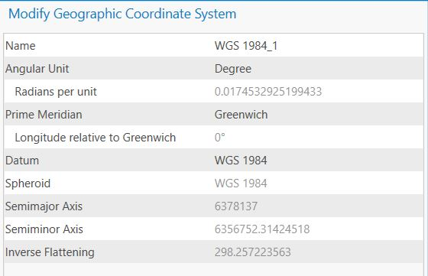

- Here, you’re presented with additional information on the projection, including the semi-major axis (how this projection measures the radius of the Earth at the Equator), the semi-minor axis (how this projection measures the radius of the Earth from the poles), and the angular unit used within the datum.

Question 8: What is the semimajor radius of the Earth in the North American Datum 1927?

Question 9: Why do different datums use different radii?

Part H, Lab Production: Finding Farmer William’s Fields
Working with Field Data and Managing Projections

Link to Video Walkthrough

You are the GIS Analyst for the Natural Resource Conservation Service in Montana. You’ve been asked by a local farmer to determine the number of different soil polygons, and the names of the soils in each of her three fields so that she can better determine her fertilization requirements.

Data:
You have two spatial data files which are in a directory called Montana Soils.
- fields = which the farmer created by using her GPS unit
- Montana_soils_utm = the soils in the vicinity of her farm
- You will also need the names of soil types listed in MT_soil_names.csv.
- There’s also a metadata file, MT_soil_metadata.txt, that might provide some useful information if you open it through Windows.

Questions to be turned in:

Turn in the answers to questions 1-9 (above in the lab) and 10-12 (below and next page), along with your map (details next page).

Question 10: Name all the soil types in West Williams Field

Question 11: Kobase Silty Clay Loam (on 0-4% slopes) is the best soil for farming. How much land area (in square meters) of this soil type is available in all three of the Williams Fields combined?

Question 12: Explain how you found the answers to the previous two questions.

Map to be turned in:

Create a map for the farmer showing her fields and the different soil types in her fields. Include a title, legend, north arrow, and scale bar. Export your map as an image file and insert it into a word doc containing your answers to all questions.

University of Massachusetts – Amherst, ArcGIS Pro Edition Written by Forrest J. Bowlick, Bethany Bradley, Sophie Argetsinger, Steven Bittner, Brit Laginhas, Chloe Thompson, Connor Hughes, and many others
This seems like splitting hairs but is very important to keep in mind. Showing purely Latitude/Longitude is NOT a projection!
To the point where different datums couldn’t even be displayed together! It’s something of a GIS generational divide – you will find that people who have been using GIS since the early 90s are very particular about projections. We don’t have to be as picky about our datums these days – but the caution is warranted.
If you’re on a virtual desktop, add the .tif. If you load Mt. Holyoke and it looks, say ‘psychedelic’, change the symbology to a stretched ramp (say, elevation) that makes more sense. Groovy!
Yes, you really can think about it like laying a cone on top of a globe!
Meaning the data is not being formally reprojected, which you’ll do later.
So, you can have as many different files with as many different projections loaded as you want, but Arc can only display one projection for the entire map.
This is why some projection issues have popped up in labs so far.
Right click on file in table of contents -> Zoom to Layer
There’s only so much I can do to emphasize things in text.
Right click -> Zoom to Layer
If they still look square to you, you might have missed a step…ask for help.
Remember this for a few questions from now.
6,000+
Whatever that means
You have been peeking at these in the coordinate systems tab.
Eh
Suspenseful page break
If you try to use the other one it won’t work because it’s for vector data.
The tool for projecting a vector file is different than the one for projecting a raster file.
If it asks for a geographic transformation, you’ve made it very interesting. See what happens!
You should really stop doing that.
Insert tab > New Map
It should.
Vital, otherwise who knows what projection information you’ll absorb.
No better way to start off an ArcGIS session than with an error message.
These are the files you see in windows file explorer, but not in the catalog window.
Or, if you didn’t reset your projection like the lab asked, somewhere near the 0,0 mark of the coordinate system you’re currently in.
They are a mystery because of the ‘unknowns.’ This is like the worst episode of Scooby-Doo.
Hint: What are the units of a GCS?
Ha
You will
Projected Coordinate Systems -> State Plane -> NAD 1983 (US Feet), then find the Rhode Island option.
You saved a copy, right? Don’t worry, you can always download another…
This is a bug that can cause massive frustration: often, you’ll scream ‘but I defined the projection!’. Updating the data frame usually clears things up.
If you don’t do this you literally cannot answer these questions.
Symbology
Remember that the native coordinate system is the one the files comes with. In other words, the data are encoded in the native coordinate system (whether or not that information is provided).
You may have to click the ‘Add all values’ button under Classes.
You could click to see what other zones cover parts of Mass.
Eventually the distortion reaches infinity. Yikes!
Another way of asking this question might be, ‘What UTM zone is Lesotho in?’
You aren’t done, the production starts on the next page.
Do you think this activity is really about soil? No! It is all about projections, so expect some problems with the definition of the projection for your spatial data that you will need to fix before you can complete the analysis.
Hopefully you know by now that this isn’t just a suggestion.
Think: How could you isolate just the West Williams Field? Is there a way we can select features by an attribute? By a location?
Think: How could you create a new file containing only a cut out of the soils in the fields? How would you calculate the areas of these new field polygons to ensure your data is correct?
Soil map legends are… rough. Do your best but don’t obsess.

