Introduction to GIS: Lab 1

Data, Software, and Map Theory

Organization of data, setting up software, and understanding the potential of the maps you will create are essential components key to success in Introduction to GIS. This first lab provides a foundational context for the work we are doing in this course, namely how GIS data work and operate in a Windows environment, how you can access and navigate the ArcGIS Pro software, and how the maps you make and use function as communicative and designed objects. As you’ll be interfacing with all these components in this class and in your future GIS work, each deserves time and attention at the beginning of the course.

This lab is divided into five parts, which you should complete in order:

Part A: Data basics: Storage, organization, and other fundamentals

Objective: Understand where and how files, both downloaded and created, are stored on your computer, while interfacing with file archives and “unzipping” a compressed folder.

Part B: Course software: Starting ArcGIS Pro

Objective: Explore how you are going to access our course software, ArcGIS Pro, and some other software necessary to ‘do’ GIS for this semester.

Part C: Introduction to the ArcGIS Pro Project

Objective: Become familiar with the “look and feel” of the ArcGIS Pro software interface by examining foundational components of the interface.
Part D: Introduction to Maps and Mapping

Objective: Begin to understand what a map is, what kinds of information a map can communicate, and what makes an effective (or even good!) map.

Part E: Lab Production: Putting it All Together

Objective: Consolidate your screenshots, answers to questions, and map explorations while creating one last map to finish off your production document.

You will find questions to answer throughout this lab formatted Like This. Please answer these questions as you encounter them, otherwise you’ll have to do a lot of backtracking! You will compile the answers to your questions (which will include text, screenshots, and maps) into one single document at the end of the lab and save that compilation as a .pdf for submission on Moodle.

Part A: File Storage Basics

Summary: Practice the basics of how and where your computer stores files, including those that you create and those that you download, while interfacing with the functional, but at times confusing, compressed folder. Learn why it’s never good to work out of a folder that has not been un-compressed!

Geospatial Technology Competency Model: 5.1.26, 4.1.11.3, 4.1.11.4, 2.8.6, 2.8.1, 2.1

Link to Video Walkthrough

Welcome to Introduction to GIS! So far, you’ve accomplished exactly what you needed to – you downloaded this word file. Lab files are always shared as word documents so that you can write notes, make comments to yourself, add answers to practice or production questions within the document, and otherwise enjoy having a workspace you can control.

- Before you proceed – make sure you can edit this document. Word prevents you from editing documents downloaded from the internet, because the internet is a scary place. If there is a yellow bar across the top of your screen that says, ‘protected view’, please enable editing by clicking the button that says ‘enable editing’ (example below).

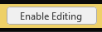

- Now that you can edit your document, you’ll notice that there isn’t any GIS data here. Instead, we store GIS data in other formats than .doc and .docx. These formats are complex, contain many parts, and are often large in file size. So we need a different way of handling that information to work with it in GIS.

- For GIS data in this course, we use folder compression with the ‘.zip’ file extension to share our data. These ‘zipped’ folders will contain all the GIS data and other information you need to complete a given lab each week. In fact, the very lab document will be in the zip folders in the future. Magic!

- If you haven’t already, download the lab 1 data zip file from the course github site. Depending on the setup of your computer, browser, operating system, etc., it might download in the same place as this file. In any case… we need to find the zip.

  - One easy way to find where your downloaded file went is to check through your browser. In Google Chrome, you can choose ‘show in folder’ from the options provided when a file downloads, and it will directly open the file directory and show you where the file lives. Cool!

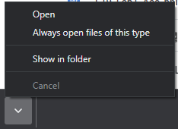

If you’re working off the campus computers, the file is most likely in your “Downloads” folder, along with this document. It’s not the worst place for a file, but certainly not the best.

If you’re working on your own computer, it might also be on your desktop, or somewhere else entirely! Maybe your browser asked you where to put the file, or maybe it didn’t. You’re going to need to know where you told your system to save the download.

Question One: Where did your zip file download? Why did it download there?

When you track down your Zip file’s location and double click on the zipped file, it will open a window that shows you what is inside. THIS IS THE DEVIL’S SNEAK PEEK. Never do your work out of this preview page. You’re only looking at your data – but because that data has not yet been unzipped (or decompressed), you can’t do anything with the data. Useless!

- You can tell that it is a preview because:

  - You have not yet “unzipped” the folder, and
  - There is a button at the top of the file explorer that says, “Extract all”, which depending on your colour scheme, might look something like this:

- Compressing, or “zipping” a folder makes the files in the folder take up less memory. It also treats this entire set of files as one single entity – the .zip. This is useful, especially when you are emailing, storing, or downloading a lot of information (which you will be in this class!). However, your computer cannot easily read or ever edit files that are compressed. To work with a file, it must be uncompressed.

- To unzip the folder, click “extract all” at the top of the file explorer. Windows will then prompt you to choose a location and name for the extracted (unzipped) files.

- Now… where should we put these files? Once they’re unzipped, they’re ready to be worked with. But we also need to put these files in a place where they can be easily found, transferred if necessary, and accessed for future work. Nothing more frustrating in GIS than losing your data!

- If you feel comfortable with data management, storage, manipulation, and so forth, feel free to unzip your files and organize them per your preferred practices – the steps below might still be helpful!

- However, if you’ve never worked with zip files before, feel uncomfortable with data archiving, backups, managing file paths, etc. – please follow the below steps for useful storage information. Our primary goal is to never lose our GIS data. We will remain in control of our information!

- Back to the extracting. Windows will offer up a default folder it proposes to create when you hit “Extract all”, that looks like this:
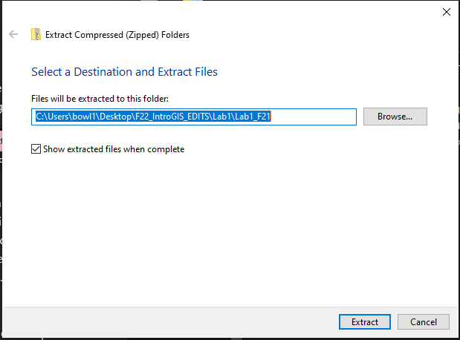

- While occasionally such suggestions are useful, here it’s clearly a mess. Click the ‘Browse…’ button next to that file path, and let’s explore some simpler options.

- The new window that appears is titled ‘Select a destination’, and as that implies, it has opened the full file explorer for you to… select where these files are going to go. It shows the whole file tree and everywhere (and everything) saved on the computer. Cool!

- You’ll note some spatial language in these descriptions – file explorer, file path, etc. These are ways we describe where our files are saved on the hard drive. Unlike on a smartphone, or when using cloud-based systems like a Chromebook, files on Windows systems exist on the hard drive with a specific, known location. Changing that location means the file can’t be found.

- For example: when you move the location of an App on your iPhone’s home screen, the App keeps working – but if you move the folder where your GIS data is stored, your maps will not keep working.

- By ‘file path’, we mean the location of where your file is – like a web address, just referring locally to the computer you are working on.

- By ‘file explorer’, we mean the ability in Windows to see the structure and organization of all the files on the system.

- By ‘file tree’, we mean the structure of the files on the computer. Think of it like a series of branches, with each part of the file path referring to a new branch from the trunk (or drive) where the files are stored.

- Let’s browse ourselves to an easy to locate position – the desktop. Desktop refers to what you see on the screen when you log in to windows, and it is also a specific location in the file tree as well. You can find it under ‘Quick Access’:

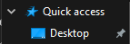

- Or, under ‘this PC’:

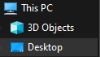

- Click the Desktop and the window will update to show the desktop file tree and everything there:

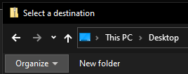

- Choose the ‘New folder’ button. We’re going to make a nice new home for our GIS data.

- When you click ‘New folder’, a new folder will appear named… ‘New folder’. Super helpful, Windows! We’ll need to rename that so you can keep track of what you’re doing. As this is the first lab, a name like ‘GIS_Lab_1’ would be great. You make your choice about names, but follow two rules:

  - No spaces in the folder name, and
  - The folder name cannot start with a number.

- With your newly made folder all ready, click ‘select folder’ on the bottom.

- The extract dialogue from before will reappear with your nice, new, helpful, organized file path, placing the data exactly where you want it to be:
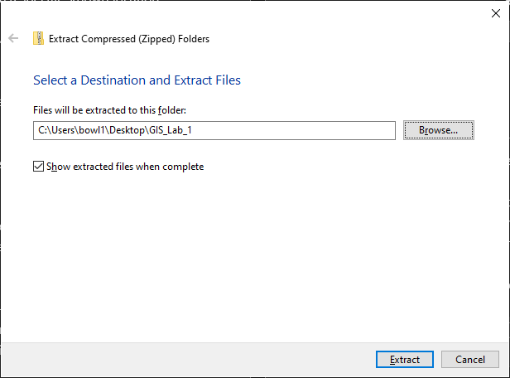

- Hit extract, and you and your data will be ready to go! In fact, the new file explorer window will appear with your file path, and your extracted data already for analysis:

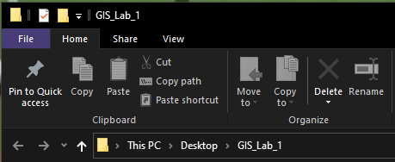

- To rezip a folder, just head back to the folder you want to zip up, navigate to the ‘share’ tab, and click ‘Zip’. If you want to Zip up multiple items, select them all in the file explore Window, then click ‘Zip’. Easy!

- Question Two: What is the file path where you extracted your GIS data? Write it out in the format like you saw in the extract window.

- The Desktop is generally an easy place to put your data so that you can find it at the end of your lab for rezipping, backing up, and so forth. On your own computer, you might have a preferred storage method in some other way. And on the virtual desktop, you will need to set up a folder in One Drive rather than the Desktop. But the practice of setting up a place to hold your data will always be relevant.

- As it stands, we’ve accomplished a lot! We downloaded our data, organized our files, and are ready for analysis. Awesome!

Part B: Course Software: Starting ArcGIS Pro

Summary: In this part of the lab, you’ll boot up ArcGIS Pro, and learn a few ways to access ArcGIS Pro in different contexts. You’ll also learn a little about some solutions for backing up and transferring files between computers.

GTCM: 4.1.6.8, 2.8, 2.4.2.1

Link to Video Walkthrough

- Now that we have the data ready, we can start thinking about working in ArcGIS Pro. Exciting! Depending on how you’re accessing the software, there are a few different steps to getting up and running with Arc. We’ll go from easiest to hardest – practice the one you’ll be using but be aware that many options are possible! Feel free to skip the sections that are not relevant to how you’re planning to work with the data.

Accessing ArcGIS Pro from campus computers

- If you’re working on a campus computer, great! ArcGIS Pro comes preinstalled. Click the start button in the lower left of your screen (the Windows icon) and look for the folder titled ‘CAD & GIS’. Open that folder and select ‘ArcGIS Pro’ to start.

- When you boot up Arc for the first time, it will ask you to login. We license ArcGIS Pro through our license server – fortunately, we have an easy way to login using existing UMass credentials. No new passwords to remember here!

- The login window that will appear will most likely look like this:

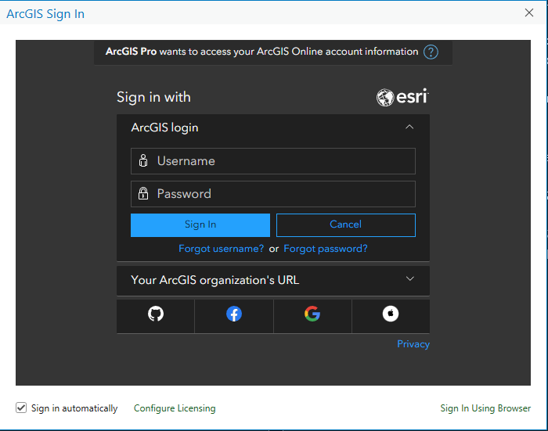

- Though it’s possible you’ll get this screen with a blue error message in the right corner:

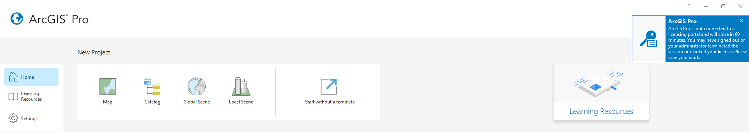

- If you see the second screen, click ‘sign in’ top right – you’ll be led to the first screen. Once there, click open the ‘Your ArcGIS organization’s URL’ option, and enter our organizational URL: umass-amherst. It should look like this:
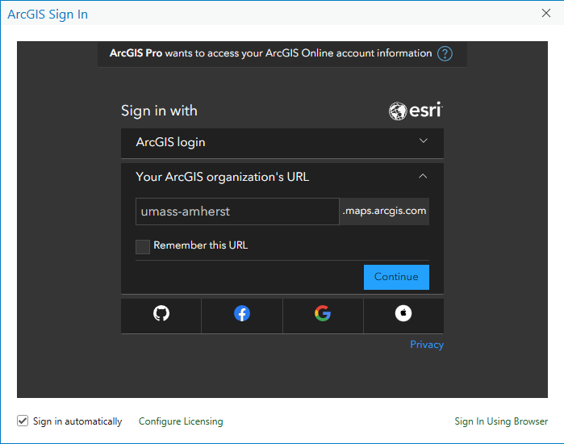

- Click continue. Enter your UMass credential as usual, making sure to add the ‘@umass.edu’ to the end of your NetID:
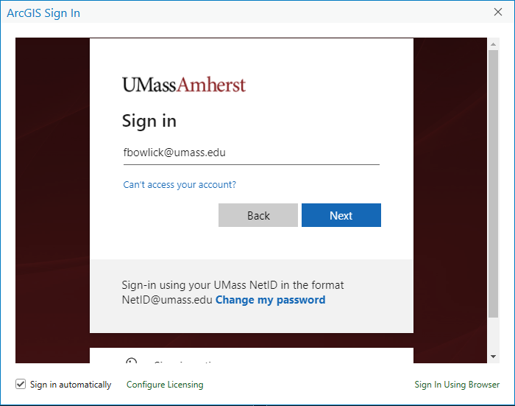

- Login and authenticate as usual. Once you complete your login, ArcGIS Pro will appear with your information in the top right corner. Success! You’ll remain logged in on your profile until you log out, or until IT decides to reset you. Which could happen anytime, so remember these login steps.

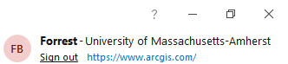

- If you’re working from a campus computer, and successfully logged into ArcPro, skip to the next section!

Accessing (and installing) ArcGIS Pro on your own computer

- If you have a Windows computer that meets the minimum specifications for ArcGIS Pro, congrats! You can install a copy on your own computer. Install any Windows updates you’ve been avoiding (the upgrading to Windows 11 is not currently recommended). Then, you’ll need to request a license and download the software.

- Here are the handy links with associated walkthroughs to get you going:

  - ArcGIS Pro minimum requirements
  - ArcGIS Pro license request
  - ArcGIS Pro installation instructions
    - You may also need the updated .NET runtime, available here: Windows x64 .NET runtime 6.0.6

- If you’ve installed Arc on your own computer, and successfully logged in, skip to the next section!

Accessing ArcGIS Pro from Remote Desktop

- If you have a Mac or Linux computer, or a Windows computer that doesn’t meet the minimum specifications, but you do have a stable internet connection, you can use the virtual desktop to access ArcGIS Pro. The virtual desktop offloads all the processing to a remote server and turns your web browser into a tunnel to control everything that’s going on.

- Follow the instructions below to request access and set up your virtual desktop access. Please note that it takes some time between requesting access and being granted access, so do not expect to start working on the virtual desktop immediately.

  - ArcGIS Pro virtual desktop access instructions
  - Follow the instructions to activate your OneDrive account below. OneDrive is an online, cloud storage system integrated into Windows computers. The UMass virtual drive uses this to store your files, as the virtual drive has no physical media (it’s only simulating it!)

- Navigate to the Online File Storage & Collaboration page to set up your OneDrive account. Click the Sign in button at the top of the page:

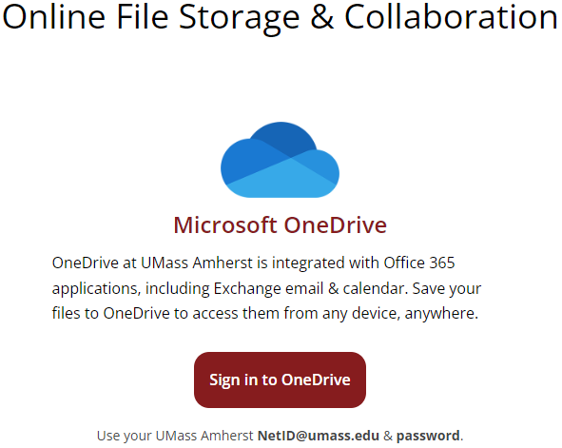

- When you have successfully set up your OneDrive account, complete the following:

  - Log in to UMass OneDrive and navigate to the “My Files” page. In browser, it looks like:
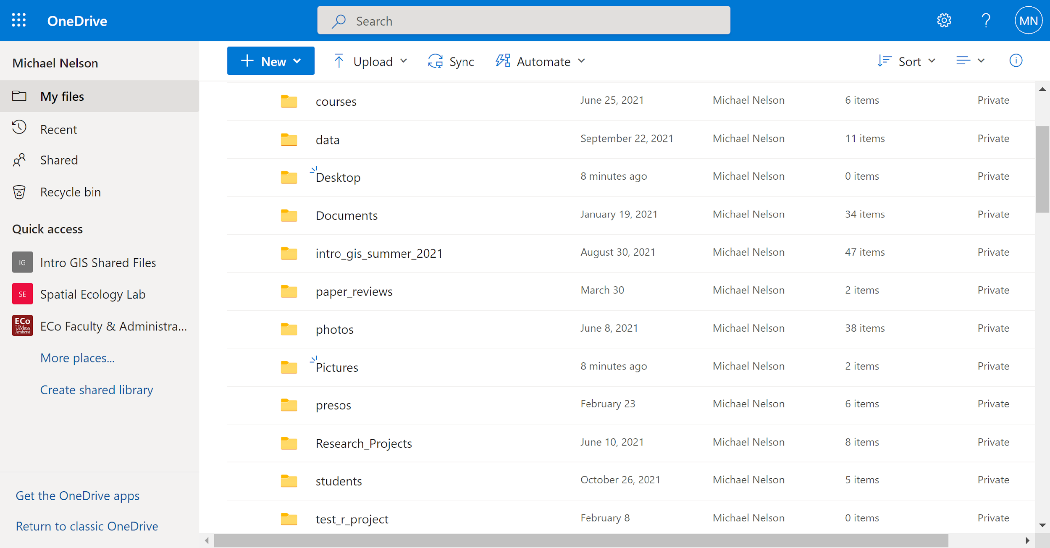.

  - Using the + New dropdown menu, create a new folder. Name the folder “Intro_to _GIS”.

  - Follow the instructions for unzipping your data as described in Part A, only unzip all your data in this folder you just created. Anything left on the desktop will be deleted when you log out of the virtual drive.

  - If you’re working from the remote desktop, and have completed the virtual drive sign up and one drive login, skip to the next section!
Part C: Introduction to the ArcGIS Project

Summary: Work in ArcGIS Pro is centered around projects. A project is where you store maps, layouts, connections to databases and GIS servers, and so on. You can store multiple maps and layouts in a single project. Use this short walkthrough to see some of the highlights.

GTCM: 5.2.24, 4.1.6.8, 3.5, 2.8.5

Link to Video Walkthrough

- When you start up ArcGIS Pro, you will not see a map, or data, or anything really – just several options for how to start your session. Since ArcGIS Pro doesn’t have a beginner’s mode, a tutorial, or difficulty sliders, we have the same options expert GIS users do when we start the program. Fun? Fun!

- You can choose to start a new project from a blank template (Map, Catalog, Global Scene, or Local Scene), or to start without a template. If you choose to start without a template, you can save your project later.

- Since this is our first GIS rodeo, let’s click ‘start without a template’. While we can save it later, we’re mostly just going to get familiar with the layout right now.

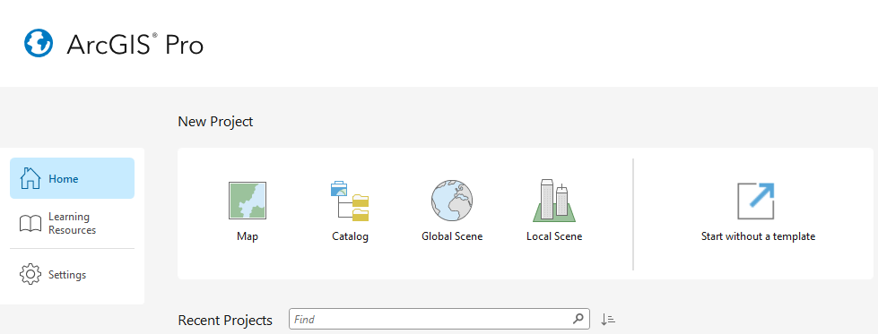

- Starting without a template is the fastest and easiest way to start up ArcGIS Pro. The only downside is that it starts completely blank – great to practice with, but less useful for getting our data storage and analysis options set up. In future labs, you’ll start things differently.

- The window you have is stark – a document titled ‘Untitled’, no map or layout in sight, no data or analysis prepped. Like a GIS ghost town.

- Let’s add some features. Click ‘New Map’ in the Insert Tab’s Project Group.

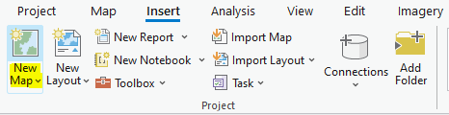

- When you click ‘New Map’, a new map appears. Conveniently, it is centered on UMass. Zoom in until you can see the names of buildings and trees on campus. If you’re attending lab in person – can you zoom to our class lab on campus? Maybe zoom to other campus features you’re interested in as well.

- Sometimes, all you need is a quick map capture to send someone for information, analysis, or other uses. Let’s use a quick feature in the software to capture a view. First, adjust your map zoom until you have a view that includes:

  - The UMass Campus Pond,
  - All four Morrills, and
  - The DuBois Library

- Once you have this view set, right click on the map view and choose ‘Capture To Clipboard’. If you hover over that option for a second, a help tip will appear explaining more about what the option, tool, or analysis does. Very fun!

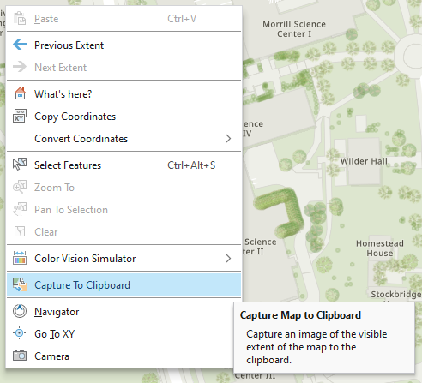

- Once you make the ‘Capture To Clipboard’ selection, your map view is stored in the system clipboard. The system clipboard is where things go when you ‘copy’ them. They’re also what are placed when you ‘paste’ something. So, on the next page, paste your new capture!

- Question Three: Paste your capture from Arc into your lab report!

- Another thing we can do with the basemap is change what is being displayed. Right now, we’re looking at the ‘World Topographic Map’. But there are a lot more options. Let’s change it up.

- Under the ‘Map’ tab in the ‘Layer’ group, click ‘Basemap’. You will see… many options for what your basemap could be.

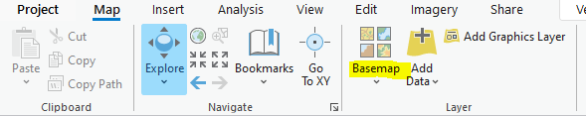

- Pick one and notice how your map changes. In fact, let’s share this map too! But we’ll create our screenshot in a slightly different way.

- You noticed in the last copy option we only saw the associated map. Sometimes, when troubleshooting, sharing setting details, or doing other work, we need to see the user interface in addition to the mapped information.

- Let’s pull up a tool that allows us to capture more than just the map. Head to the start button again, and scroll down to a folder titled ‘Windows Accessories’. Inside you’ll find a tool called ‘Snipping Tool’. Click it!

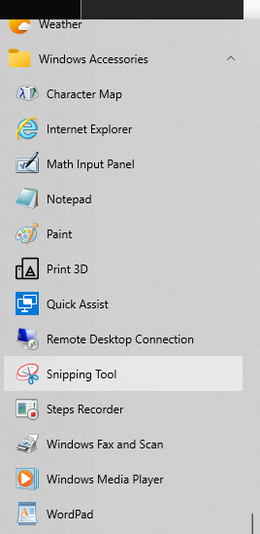

- The Snipping Tool is another Windows program that allows you to capture what’s on your screen. Use it to capture not only your updated map view, but also the Contents pane which tells us which basemap you are using.

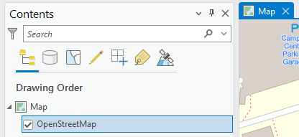

- Question Four: Copy and Paste your Snipping Tool result of your updated map and the contents pane from Arc into your lab report!

- What an exciting time of map making and screenshotting. Let’s close out of this project before we move onto the next section. Click the X in the top right of the screen to close Arc. We don’t need to save our changes – you do have the screenshots after all. When ArcGIS Pro has closed, move onto the next section.

Part D: Introduction to Maps and Mapping

Summary: GIS is all about making maps (among other things, but most of them are map-related). You should know the basics of what a map is, what maps can be used for, and what makes a map useful, before we start!

GTCM: 5.2.24, 4.1.14, 4.1.5, 2.8.8,

Link to Video Walkthrough

      - While exploring a blank map is a great way to learn something about the look and feel of the software, it’ll be much more useful to play with some data.

      - In this section, you’ll work with some premade layouts, adjust some symbology, design components, and learn more about the fundamentals of mapping. People made maps ages before GIS, and those practices still make sense within our GIS space.

      - Further, we’ll explore some more data formats and ways of storing GIS data. By the end, you’ll be able to confidently take on the rest of the semester!

      - In the ‘Part_D’ folder in your downloaded files, open the Packaged Project File (.ppkx) titled ‘Counties’.

      - Packaged Project Files share not only GIS data, but styles, analysis, and other information in a conveniently compressed package. They are fancy GIS specific compressed folders that make sharing data and information easy!

      - When you open this file, you’ll see a map of Massachusetts counties.

      - Question Five: Do you think this is an effective map of Massachusetts counties? Why or why not?

      - One thing we can agree on about this map is that there are a lot of colours going on! Colour on maps can be a powerful way to draw attention to certain aspects of a map, highlight key data points, or build a formal design to a map document. But it can also be a major challenge to balance how to choose colours that effectively communicate ideas.

      - Another thing to consider when using colours is how people with different color vision end up seeing the map. Right click on the map and select ‘Color Vision Simulator’ from the menu. You’ll see three options to simulate. Note: your version of Arc may not have the Color Vision Simulator. If you don’t see it, proceed to the next step for an alternative.

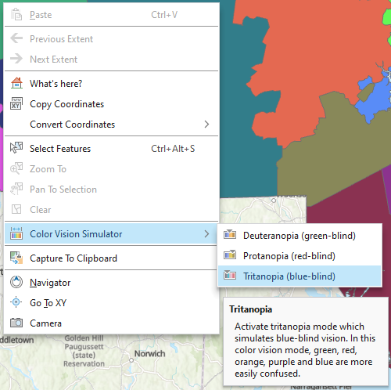

      - If your version of Arc doesn’t have the Color Vision Simulator, you can use this website to get a similar idea of how the different ‘opias’ work: COBLIS

      - Question Six: Can you tell the colours apart on the county map (or in the website example) under each of these colour vision simulators?

      - It might benefit us to change the colour scheme to something more accessible. Exit the colour vision simulator (use the red x in the top right of the map pane).

      - Next, let’s adjust our colours. In the contents pane, right click on the layer name, ‘COUNTIES_POLY’, and choose ‘Symbology’ from the many options. Symbology allows us to change the way items are displayed.

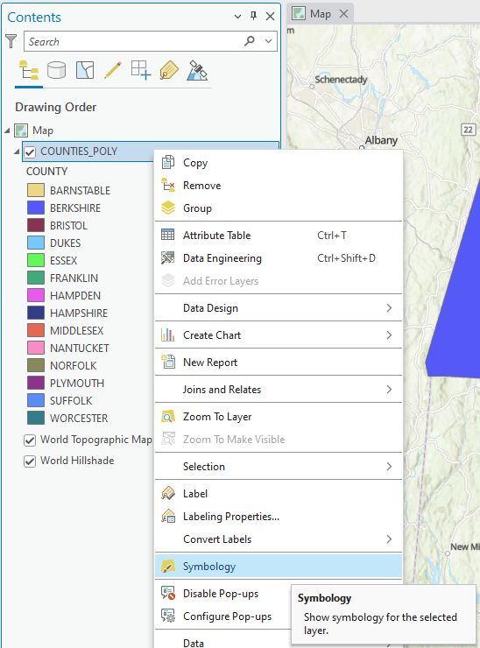

      - The symbology pane will pop up on the right side of your screen.

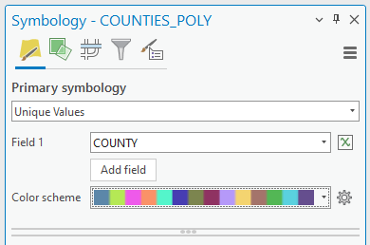

      - While many options exist here, let’s just pick a new colour scheme from the drop down. If you don’t like the base ones that are offered, click the ‘Show all’ checkbox to see all the programmed colour schemes. Click ‘Show names’ to see what these are called. Aim to pick a new colour scheme that would make it easier for someone with a colour vision difference to differentiate between the counties.

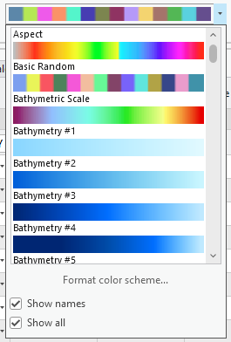

      - When you’ve made a change, close the symbology window. Your new symbology will be applied to the map.

      - Question Seven: Paste a screenshot of your new symbology in your lab report. Did your new symbology do better or worse for colour vision differences?

      - Now that you’ve adjusted the colours, we can move onto the next project. Close this one down. You don’t need to save your changes since we have the handy screenshot.

      - In the ‘Part_D’ folder in your downloaded files, open the Packaged Project File (.ppkx) titled ‘Sample_Map’.

      - In this example, let’s say you’ve received this template for a reference map to Massachusetts schools from a colleague. The goal of this map is to show the schools relative to major roads in the state. Towns will form the background. They’d like some feedback.

      - The first thing you might notice is that, while we have a lovely set of data apparent in the content pane… we can’t see anything but our lovely Massachusetts towns.

      - In this case, we’re thinking about another key component of cartography – the ordering of features. We need to present data on our map in a reasonable and readable way. And if we’re supposed to be looking at schools – we should be able to see them. Let’s edit.

      - Items in the contents pane can be moved around to change their ‘Drawing Order’. This refers to the way the system displays them in the map pane. The top item in contents is drawn ‘on top’ of the rest, meaning it will always be seen drawn ‘above’ the rest of the items in the map.

      - Since we want to see schools, it should be on the top. Click the file name where our schools are (Schools (PK-12)) and drag it to the top of the list under your ‘Map’ in the content pane. As you can see right above that, this is the ‘Drawing Order’, so we know we’re on the right track.

      - When you release, you’ll see the schools pop up on the map. Great!

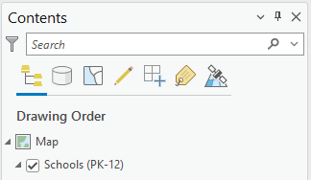

      - Now that we can see the schools, let’s bring the roads up as well. The file name here is a bit more… esoteric (EOTMAJROADS_RTE_MAJOR), but GIS data doesn’t always preference easy reading in file names.

      - Drag the roads file below the schools file. It will nestle itself under the symbology description just fine.

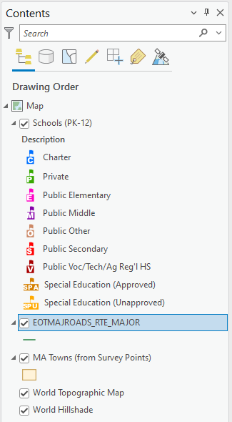
      - You’ll note all the data are located above the basemap, which we don’t need to move.

      - Another thing we could adjust is the road colour. If you click the green road line symbol, the symbology window will appear again, this time with several options for adjustment. Change the road symbol to something new – try using the search bar for any ‘road’ inspirations.

      - Finally, let’s change the colours of the towns on the map. Right now, they’re a… fine shade of peach, but something a little more muted might help the custom school icons stand out a little more.

      - Click on the square (or, polygon) town symbol under the Towns layer. The symbology window will appear again, only instead of choosing from the ‘Gallery’ of symbols, choose the ‘Properties’ tab instead.

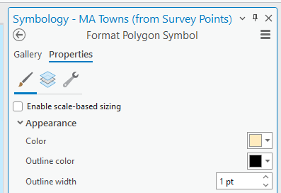

      - Here, you can more deeply customize your symbology for a layer. Change the appearance of your towns as you see fit, then hit ‘Apply’ at the bottom to see your changes in action.

      - We’ll let the custom symbology for the schools stand for now. Someone spent a lot of time doing that.

      - Question Eight: Paste a screenshot of your map with your updated symbology in your lab report.

      - Let’s move onto the last mapping example. Close this project – you don’t need to save any changes if you have your screenshot from above.

      - In the ‘Part_D’ folder in your downloaded files, open the Packaged Project File (.ppkx) titled ‘Labels’.

      - This map shows us three towns in Western Mass, as well as some bike trails. Well, it could show us some bike trails – we certainly see the labels, but not the trails themselves.

      - Fix the map using your previous skills so that:

        - You can see the bike trails,
        - Bike trail symbology is easy to understand, and
        - You can see the basemap within the town boundaries.

      - And while our map here has labels for the bike trails, our towns aren’t labeled. We’ll need to fix that. Right click on the file name for the towns (Amherst_Hadley_NoHo) and choose ‘Label’ from the drop down.

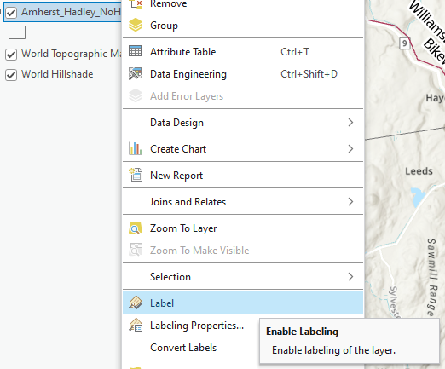

      - This will turn on some generic labels that probably won’t look great. To fix the look, select the labeling tab at the top of the ribbon:

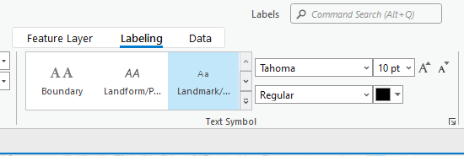

      - Labeling features is another important cartographic technique to build understanding of what a map is communicating. There are lots of label options – explore them until you decide on something that you like. Since this is a map of bike paths and towns, the labels should be of similar visibility, but not look identical so that people can tell them apart.

      - Finally, you may have noticed a new tab next to your map tab – for a map layout!

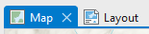

      - There are many times when the cartographic data from the map isn’t enough to fully contextualize what the map is about, or what’s happening with the mapped data. If you click on the ‘Layout’ tab, you’ll see a map design in progress. There’s a north arrow, a scale bar, a legend, and the map data – all updated with the work you’ve done. Looks great!

      - In future labs, you’ll create your own map layouts. For now, we just need to update this map with a title.

      - In Layout view, in the ‘Insert’ tab, from the ‘Graphics and Text’ group, select the icon of the letter A in a box for rectangular text:

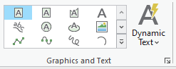

      - With this little tool, you can click and drag to make a text box anywhere on the layout. Find a nice place to put your map title (maybe ‘Bike Trails’?), and make sure to use the new text tab that has appeared along the top to make your text legible (large enough to read, standing out against the background, etc.)

      - Once you’re satisfied with the placement, let’s export this layout. We could take a screenshot, but sometimes we need maps at better resolutions or in specific file types instead of just a screenshot. Since we have a map layout, we should export this map instead of just screenshotting it and sending it off that way.

      - Select ‘share’ from the tabs on the ribbon, then choose ‘Export Layout’ from the Output group.

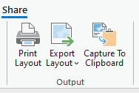

      - The export layout window has a lot of options – most importantly, you need to change the file path of where this map image will save. Change that path to somewhere you can easily track down. Change the file type to a PNG and leave the rest of the settings the same. Click ‘export’, and your map will now exist as its own stand-alone file. Nice!

      - Question Nine: Insert your exported map layout in your lab report.

Part E, Lab Production: Putting it All Together

Link to Video Walkthrough

Problem Statement: Throughout our labs this semester, you will produce maps, answer questions, and solve problems within GIS. In some cases, like this lab, the questions will be embedded throughout the document. In others, all of the questions and problems will be here at the end in the lab production.

For this week’s lab, we need to accomplish two things. First, we need to compile all the answers and screenshots you made into one document to submit on Moodle. This will make the document cleaner and easier to grade and serves as good practice for documenting your work. To do that, copy all your answers into a new document (Word, Google doc, etc.) with the answers to questions 1-9.

Second, look in the folder titled ‘Part_E’ in the lab 1 folder. You’ll see another project titled ‘Congressional’, in addition to some raw GIS data. You don’t need to work with the raw data, but seeing it in its unzipped, messy state is important. This is how GIS data looks when you are working with it on your computer. Future labs will deal with this… mess… in more depth.

For now, your task is to open the ‘Congressional’ project and create a quick map showing the towns inside of the boundaries for Massachusetts District 2, where the main UMass – Amherst campus is located. This map should show:

- The towns within the district, and
- The district outline.
Accomplish this however you see fit, and screenshot or capture it however you please. Add it to your document with the answers to questions 1 – 9. When finished, save your document as a pdf and upload it to Moodle!

University of Massachusetts – Amherst, ArcGIS Pro Edition Written by Forrest Bowlick, Ollie Murphy, Michael F. Nelson, and many, many others!
Don’t worry, the lab continues on the next page.
For remote desktop users only: skip ahead to Part B to ensure you have your access and OneDrive set up correctly. The general best practices of this walkthrough still apply.
It is just a series of tubes, after all.
Please don’t put data in word files
Bigger than a breadbox
Preferred browser of GIS Lab Authors
Often served with the devil’s lettuce
Everyone seems to have their own favourite terminology for this process: uncompressing, decompressing, unzipping, unarchiving, etc. They all roughly enough mean the same thing.
Well… you know what, just get through the class and see if you agree with this one
Use an underscore _ instead of a space
Or any illegal Windows characters – but windows won’t let you use those anyway. Numbers mean 0, 1, 2, 3, 4, 5, 6, 7, 8, and 9.
Screenshot next page
This means, depending on the system you are accessing GIS on, that you might want to do this again once we get to the further GIS work in this lab. That’s fine! Practice is always good to have when working with data.
This is the general shorthand for referring to the program. Don’t want to sound *too* corporate.
CAD: Computer Aided Design. GIS: we talked about this.
Next page, please
Basically, how the first terminal systems worked. Time is a flat circle!
Or something similar – remember our good naming habits.
Remember to login if it asks.
The tabs along the top of the ribbon store different groups of buttons which allow you to do things.
If you have no idea where any of these things are, great! Cross reference with Google Maps or another search and navigate in Arc by comparing them.
A right click is a click with the right button on your mouse.
Make sure to continue the lab after that.
UI
Windows icon lower left
Screenshot next page.
Including this, but with the whole map layout, please.
Make sure to continue the lab after that.
Quality screenshot
Used to be called ‘Table of Contents’, you’ll hear that too.
Symbols -> symbology
Hopefully you know by now – lab continues past the next page.
The state of Massachusetts, believe it or not
Wonderfully phrased, Arc
It’s over on the far right of the tab options
Why a PNG? Why not?

