Introduction to GIS: Lab 0

Course Software Setup

Setting up your software properly is key to your success in Introduction to GIS. The software setup lab is intended to help you.

Part A: Set up Microsoft OneDrive

Objective:

Part B: Set up Microsoft Azure Virtual Desktop

Objective:

Part C: Set up ArcGIS Pro

Objective:

Before you proceed, make sure you know how to take a screenshot on your computer.

The procedure for taking a screenshot on your computer depends on your operating system. You can check out this article for an overview of how to do so on most operating systems. You can also consult Dr. Google if you run into trouble.

Part A: Set Up Microsoft OneDrive

Summary: In this part of the lab, you’ll create your UMass OneDrive account and learn how to access it in a browser.

- If you haven’t already done so, you should navigate to the Online File Storage & Collaboration page to set up your account.
- When you have successfully set up your OneDrive account, complete the following:
  - Log in to UMass OneDrive and navigate to the “My Files” page. In my browser, it looks like:
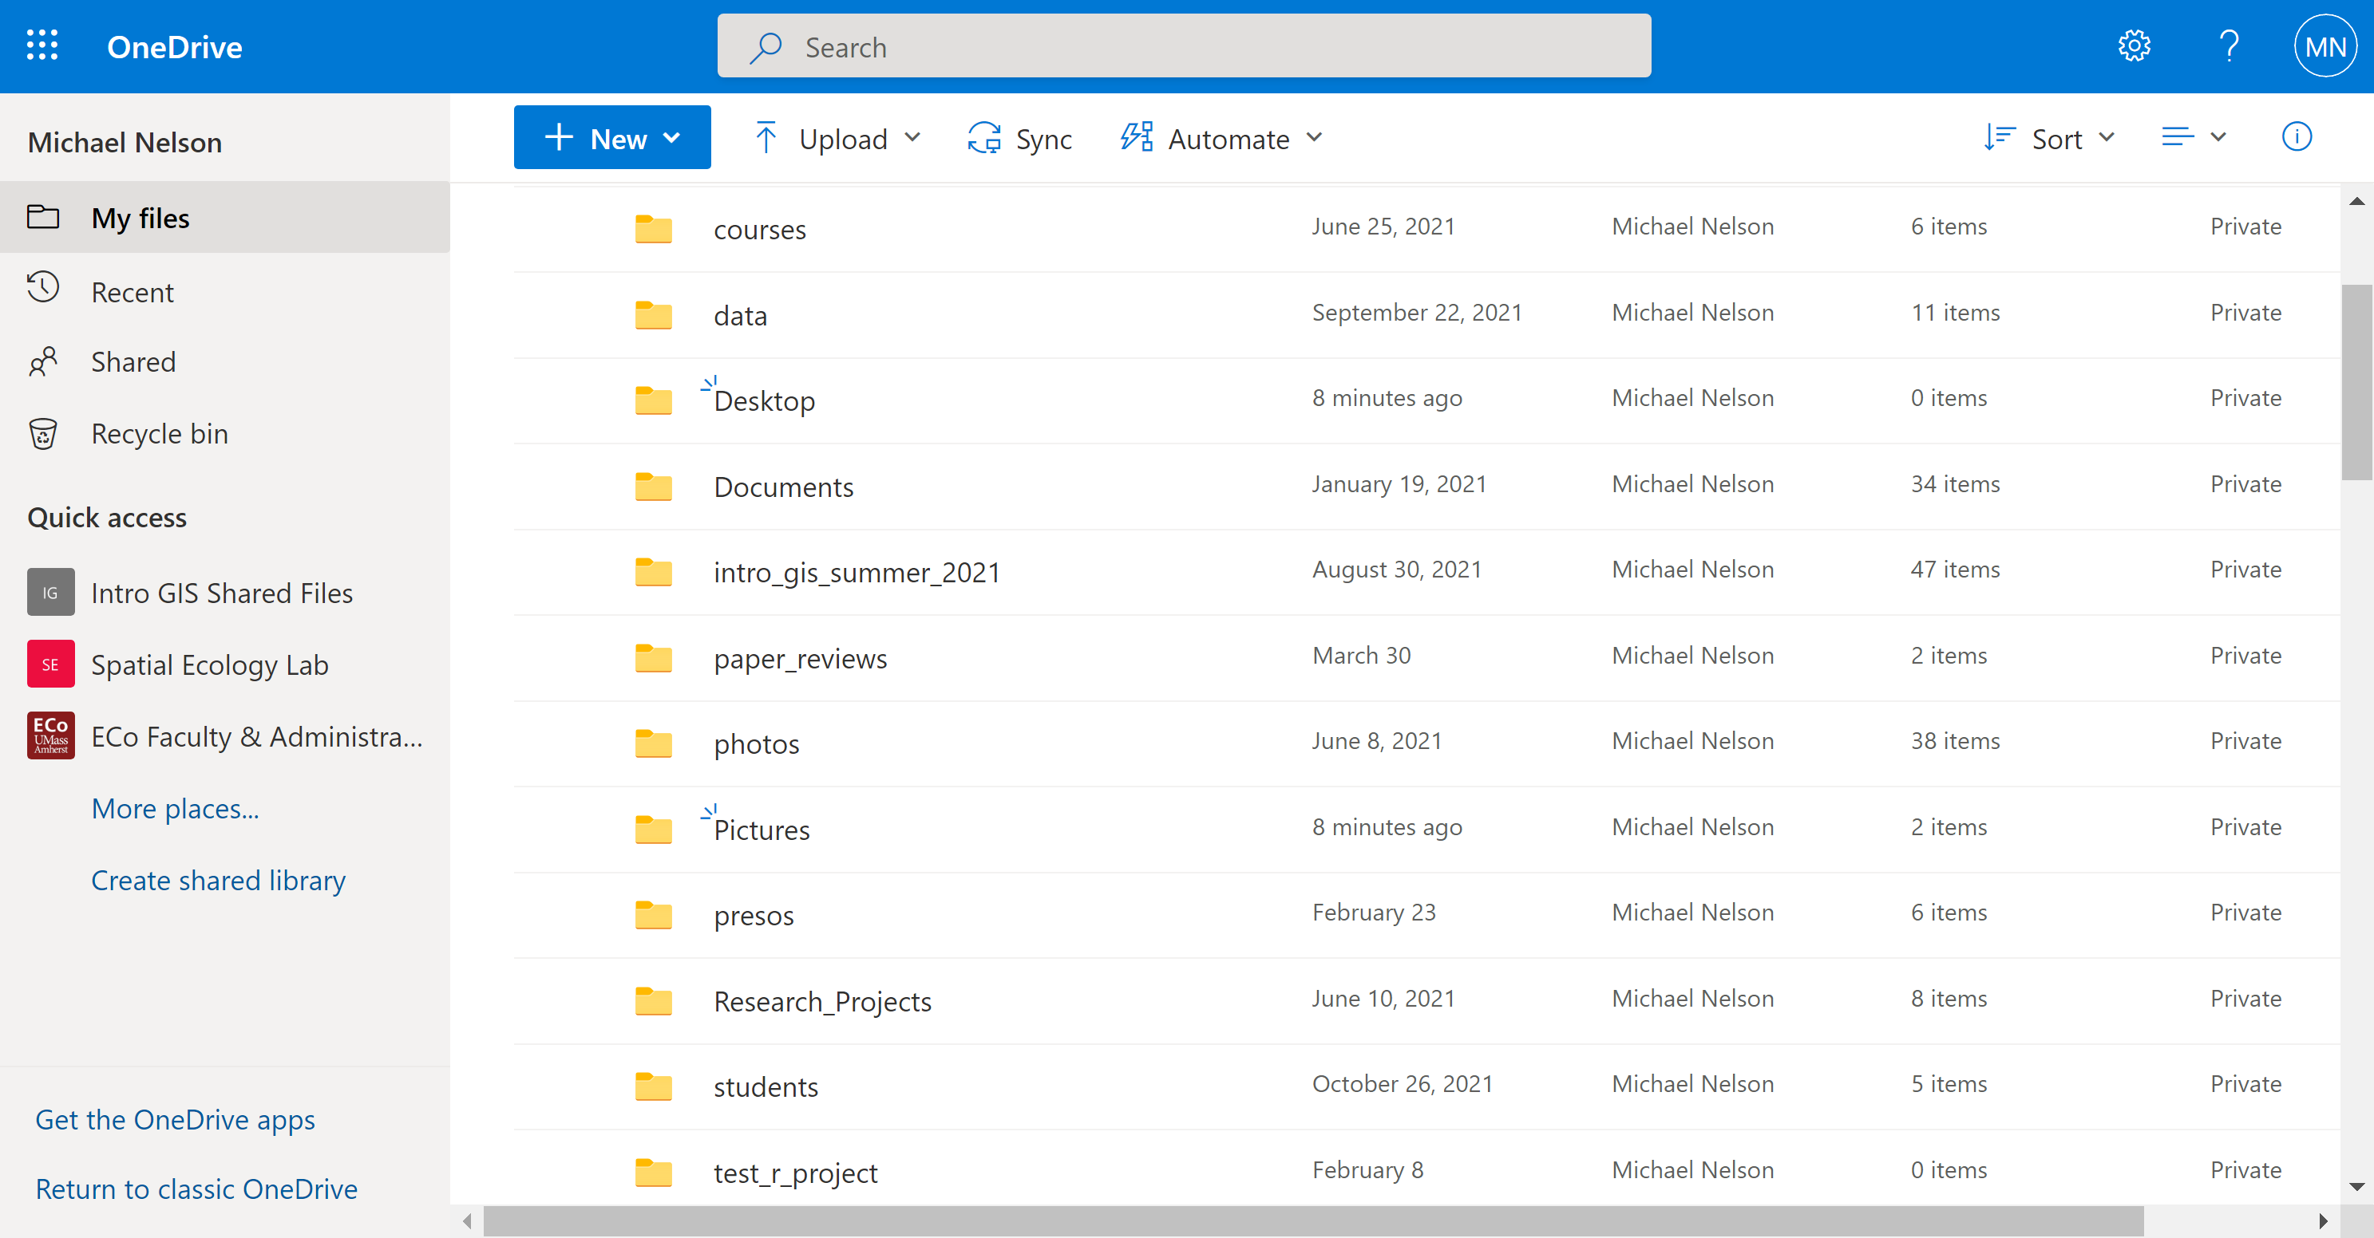
- Take a screenshot of your “My Files” page.
- Using the + New dropdown menu, create a new One Note document. Name the document hello_world.
  - Name the first page of the OneNote document Welcome Intro to GIS!.
- Write your name in the body of the note and take a screenshot. Your document should resemble:
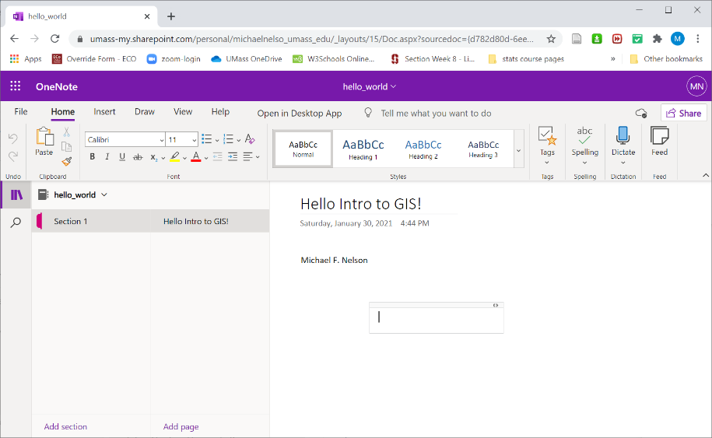

Part B: Set Up Microsoft Azure Desktop

Summary: In this part of the lab, you’ll create your UMass OneDrive account and learn how to access it in a browser.

- Navigate to the UMass IT’s Windows Virtual Desktop page and follow request access instructions.
  - You may need to provide some details such as which course(s) you are taking and which software you need access to.
  - Enter ArcGIS Pro in the textbox where you are asked to list software that you need access to.
  - You’ll receive an email once your WVD account is set up.
- When you have WVD access, log in to WVD in your browser. In my browser it looks like this:

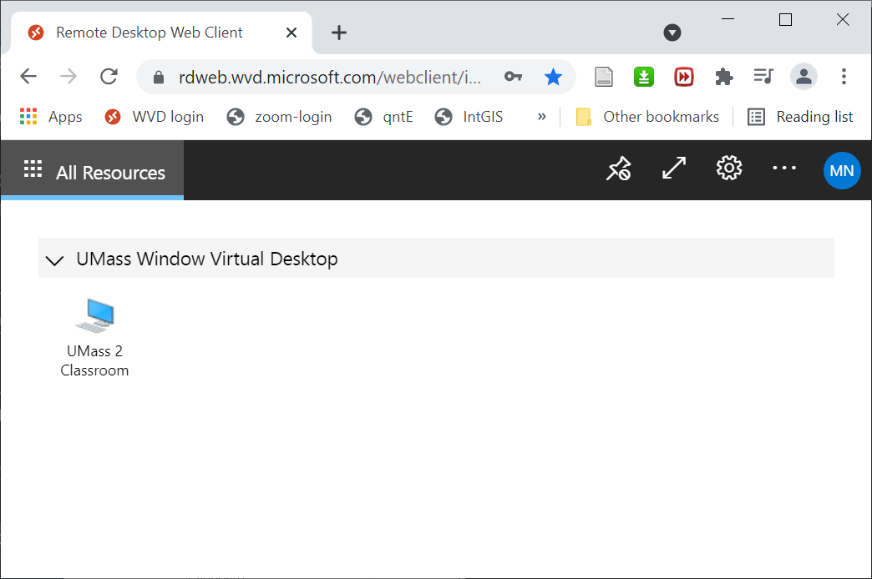

- Click on the UMass Classroom 2 icon to start a remote Windows session.
  - You may be prompted to allow your browser or the client to access resources on your computer. You should allow this.
  - You may be asked to enter your UMass credentials.
  - On my computer, WVD looks like this:
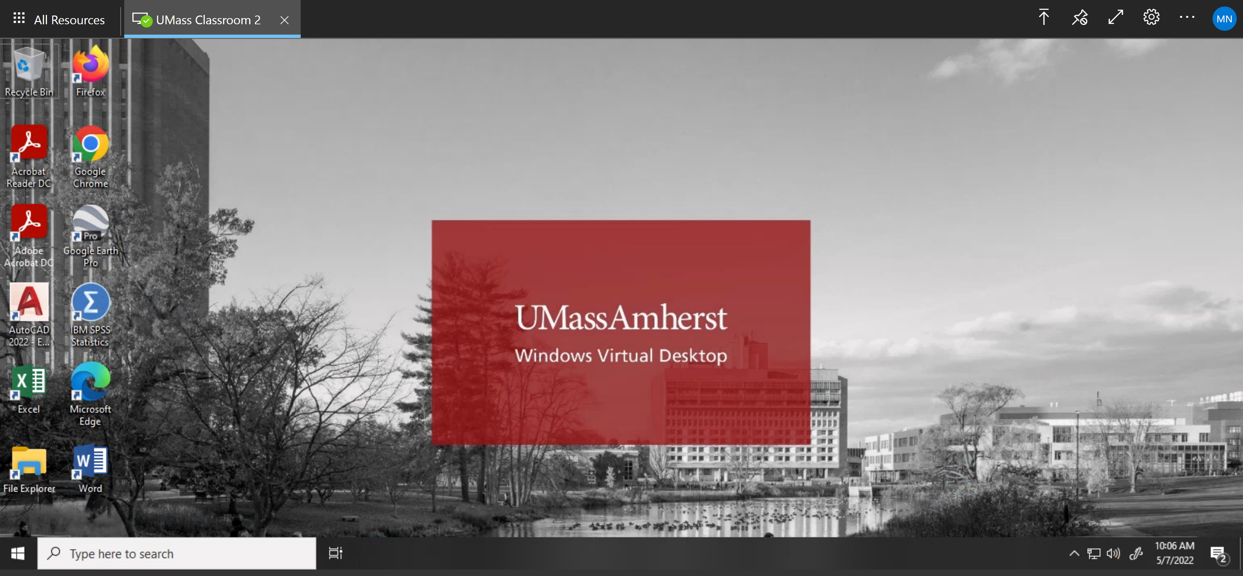

- Within WVD, double click the File Explorer to open up a file browser window:

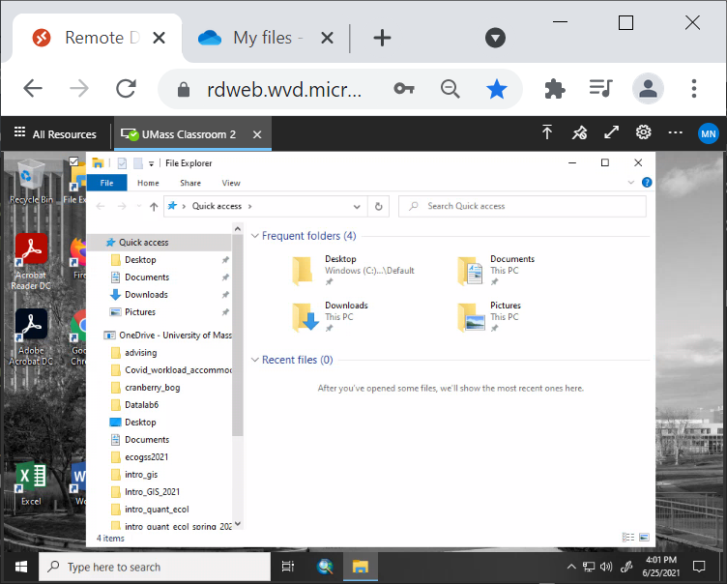

- Next, open your OneDrive folder. In the left panel, you should see an icon for OneDrive - University of Massachusetts. Click here to open your main OneDrive folder. You should see an icon for the hello_world OneNote document you created when you set up your OneDrive account.

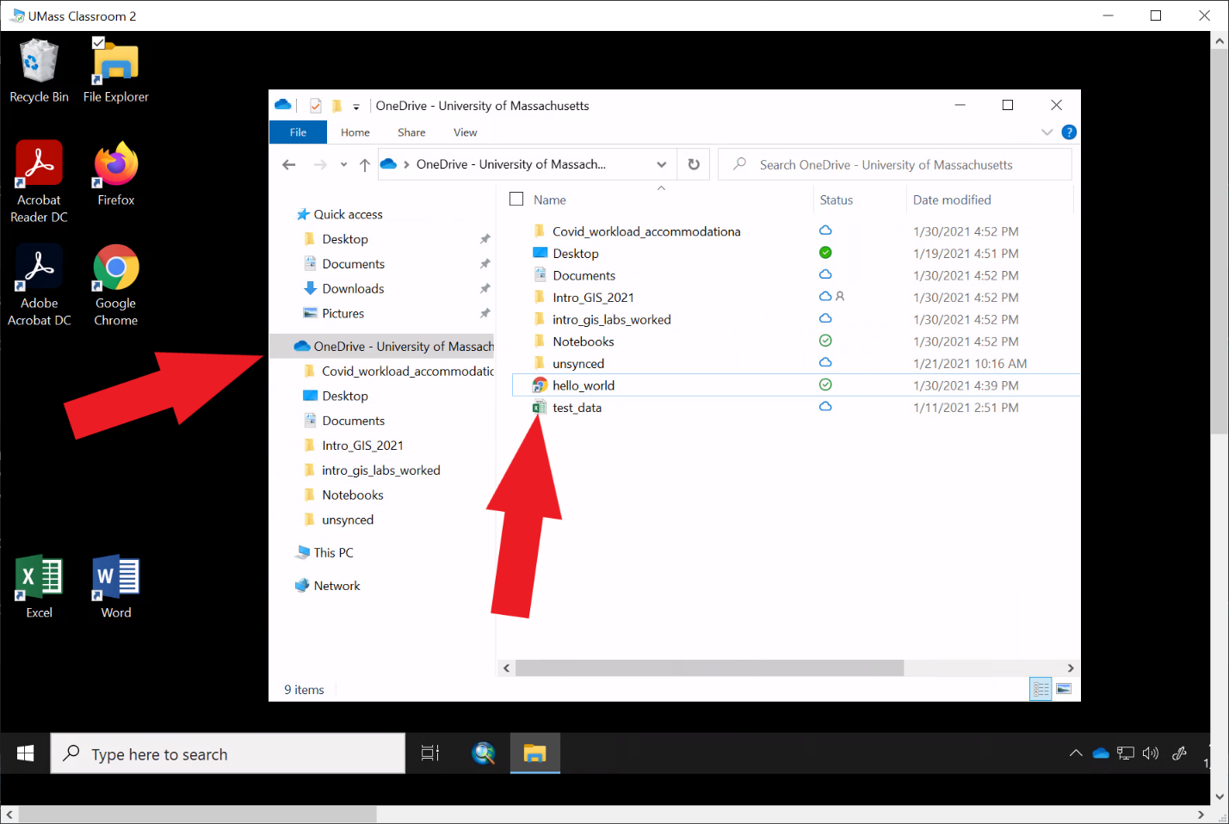

- Take a screenshot of your OneDrive folder. Your screenshot must show the hello_world document.

Part C: Set ArcGIS Pro

Summary: In this part of the lab, you’ll set up ArcGIS Pro on your computer. NOTE: if you’re a Mac or Linux user, you cannot install ArcGIS Pro on your machine, you’ll have to access it through Azure Desktop.

- Visit the UMass Geosciences ArcGIS page. You’ll find detailed instructions for how to download and install ArcGIS Pro on your machine.
- Once you’ve installed the program, launch it and on your machine and take a screenshot.
- If you’re using ArcGIS Pro on Virtual Desktop, simply launch the program within WVD and take a screenshot.

Lab Report

You need to compile all of the required screenshots into a document and submit it via Moodle.
The four required screenshots are:
- Microsoft OneDrive My Files page.
  - Your name must be visible in the upper left corner of the page.
- One Note document, hello_world.
  - The title of your page must say Hello Intro to GIS!, and your name must appear in the file text.
- Windows Virtual Desktop - File Explorer window open to your OneDrive folder. The link to your hello_world One Note document must be visible.
  - NOTE: A WVD account is required for everybody in the course, including those who plan to install and run ArcGIS on their own computer.
- Arc session. Your screenshot must show that you have successfully launched the program.
  - Note that your screenshot may be from Arc Pro running in either WVD or on your local machine.
  - You must be actively logged in to Arc Pro. The splash screen is fine, but it must show that you’re logged in.

University of Massachusetts – Amherst, ArcGIS Pro Edition Written by Michael F. Nelson

